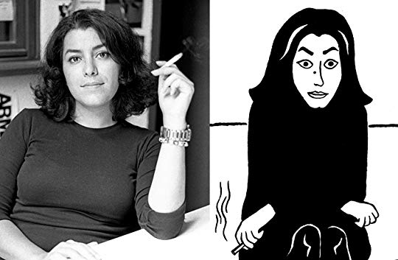
Useful
Vocabulary
from
Persepolis
By
Marjane
Satrapi
obligatory = required; must be done (p. 3)
capitalism = a free market economic system, with private and corporate ownership of goods
As well as investments determined by private decisions (4)
decadence = process of falling into an inferior condition (morally, financially) (4)
journalist = a reporter for a newspaper, magazine, news channel on TV or news website (5)
avant-garde = the first people to appreciate the newest visual, literary or musical arts (6)
prophet = a person who speaks for God (6)
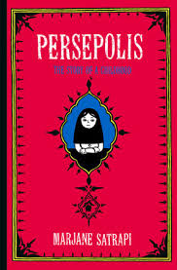
celestial = heavenly (6)
Cadillac = a big, fancy, expensive American-built car (6)
predecessors = those people who came before (7)
Zarathustra = the first Persian prophet (7)
traditional = done in a way that follows accepted customs (traditions) (7)
disciple = follower; believer (7)
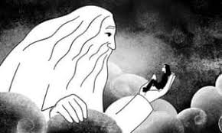
obviously = clearly (8)
disturbed = mentally ill (8)
wrath = anger (9)
unshakable = unchangeable; unmovable (10)
Che Guevara, Fidel Castro, Trotsky = revolutionaries who tried to change governments (10)
destiny = fate; what has been pre-determined to happen in life (10)
tyranny = rule or government with a dictator (tyrant) in charge (11)
submission = the act of giving up or surrendering (11)
invasion = the act of entering a place as an enemy to control (11)
imperialism = the policy of extending rule of an empire or nation over foreign countries (11)
enlighten = educate; teach correct knowledge (12)
Marx = Karl Marx, a German who wrote that workers should rebel to be treated and paid
fairly, even if the rebellion is violent (12)
dialectic materialism = a view of history as determined by the struggle between economic
forces that shape history (12)
cinema = movie theater (14)
forbade = did not allow; past tense of “forbid” (14)
BBC = British Broadcasting System (the main British radio and TV network) (15)
fanatics = people with great undoubting enthusiasm for a religion or other cause (15)
perpetrated = did or acted in a negative or unpleasant or harmful way (15)
massacre = slaughter; an action in which many people are killed (15)
participate = to take part in; to be part of (17)
degenerate = to become worse or more dangerous (18)
Monopoly = a board game in which players try to win fake money and own property (18)
putsch = a planned revolt or attempt to overthrow a government, often happening quickly
(19)
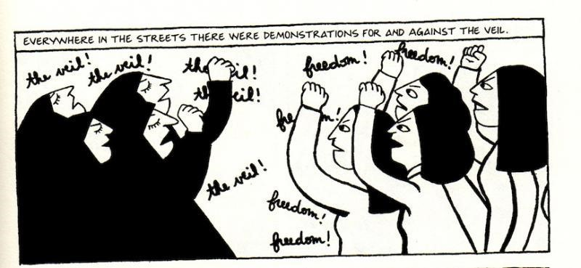
install = to put into place (19)
ideal = a perfect idea (20)
secular = not religious (20)
illiterate = not able to read or write (20)
influential = having the power to cause others to agree with you and do what you want them
to do (20)
Bolsheviks = a fanatical group wanting to overthrow the Russian government of Czar Nicholas
and fight the Russian Revolution to take over the government; members of the Russian Communist Party (20)
republic = a place in which real power is held by the voting citizens who then directly or
indirectly choose people to represent them and their interests (21)
vast = very large (21)
confiscated = taken by force (23)
entourage = a group of people who hang out with someone (23)
cultivated = well-educated and cultured (23)
rabble = a misbehaving crowd; a mob (23)
sidetracked = moved from the main direction; distracted (23)
Lenin = Russian revolutionary leader and USSR premier 1918-1924 (23)
rheumatism = a painful disease of the joints (25)
poverty = a condition of being very poor (26)
leftover material = fabric or cloth remaining after clothing has been made (27)
dynasties = a series of rulers from the same family (27)
crowned = officially made the ruler (king, shah, emperor, etc.) (27)
Aryans = Iranians (27; see also first page of the Introduction)
splendor = glory; brilliant distinction as “the best” (27)
frivolities = things done or made which are a waste of time and money (28)
impress = to make people think you are great, wonderful, brave, outstanding, etc. (28)
strictly forbidden = never allowed, no matter what (29)
incredible = almost impossible to believe (30)
martyr = a person whose death makes him / her a great hero of a cause, religion, nation and a
very important model for people to follow (31)
cadaver = a dead body; a corpse (31)
Royalist = a person who wants to have a king, shah, emperor, etc. (31)
Charles Dickens = a 19th Century English author who wrote against child labor in such works as
Oliver Twist (33)
clandestine = done in secret; hidden from view (33)
Kurdish = a group of people found mostly in Iraq and Turkey (33)
porter = a worker who carries things to earn money (33)
wove = past tense of “weave” (made something like a carpet) (33)
maid = a servant who takes care of the needs of people who live in a home (33)
peasants = poor people who live in poor conditions (35)
jealousy = envy; a feeling of wanting what someone else has (36)
bear = manage; handle; deal with (36)
clarify = to make clear or understandable (36)
Bee Gees = an Australian singing group of brothers (their name refers to “the Brothers Gibb)
Who were very popular in America in the 1970’s (36)
hesitation = pause; delay; postponement; time out (37)
social class = economic group (poor, middle class, rich) (37)
rumor = a story which people tell each other and is often not true; gossip (39)
slaughter = massacre; the bloody killing of many people (39)
reign = the time when someone is ruling (40)
declaration = statement that something is to be believed or followed (40)
revolt = rebellion; revolution; fight by many against the ruling people (40)
Freemason = member of a secret society (41)
effigy = a rough and not nice-looking statue of an unpopular person, often made of materials
that can be burned to show people’s dislike of the person it is supposed to be (41)
departure = the act of leaving or going away (41)
refuge = a place of safety (43)
exiled = forced to flee (leave) (43)
betrayed = went against; shamed; did an act against his nation (43)
pact = an agreement, usually a peace agreement to avoid war (43)
politics = the profession of people interested in being part of a government (43)
sentiment = feelings; emotions (43)
major misfortune = great bad luck; a very bad situation (44)
phenomena = unusual events (44)
succeeded = were successful; achieved a goal (44)
liberty is priceless = freedom is more valuable than any amount of money (44)
brass knuckles = a dangerous metal tool used by criminals and worn on a hand to make a
punch very painful and bloody (45)
wimp = coward; “fraidy cat” (45)
euphoria = a feeling of great happiness; much joy (45)
political prisoners = people arrested and jailed not for crimes but because they are against the
government (47)
liberated = freed; given their freedom; let out of jail or prison (47)
mistaken = wrong (49)
flatterer = someone who says nice things about you to get you to do something (49)
irretrievable = impossible to get back (49)
with seven lives = very difficult to kill (50)
C.I.A. = Central Intelligence Agency, an American government group of clandestine people
Who are involved with activities in other nations in the name of protecting American interests (such as spying) (50)
soles = the front bottoms of the bare feet (as opposed to heels, the back bottoms) (50)
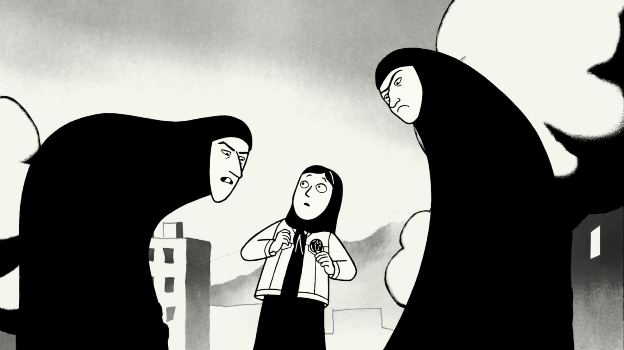
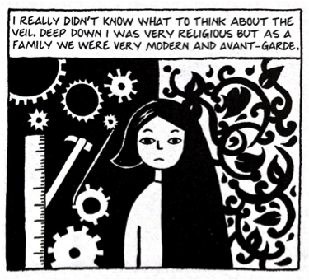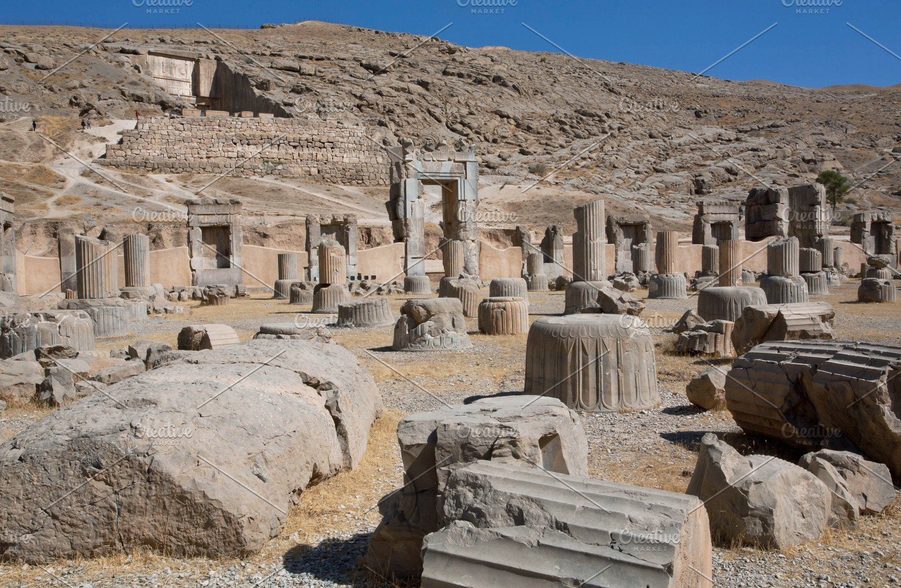

RUINS OF THE ANCIENT PERSIAN CITY OF PERSEPOLIS in modern Iran

cables = wires, cords (51)
assassinated = murdered; killed (51)
cyanide = a poison (51)
appliance = a small machine such as a toaster or microwave (51)
diabolical = evil; horrible (53)
overwhelmed = taken over or controlled by emotions (53)
justice = fairness; equal treatment (53)
reunited = got back together again (54)
proclaimed = announced or stated (55)
province = a geographical area, such as a state or group of nearby towns (55)
Azerbaijan = a nation now bordering Russia, Iran and the Caspian Sea (55)
idiotic = stupid; ridiculous (55)
tormented = tortured; made to feel lots of pain, in this story, mental; sometimes, physical (55)
refuge = a safe place; a place where one will be protected from harm (56)
U.S.S.R. = Union of Soviet Socialist Republics, a country existing from 1922 to 1991 which was
made up of Russia and several smaller nations (57)
shunned = not accepted; kept away (58)
scratched out = covered over with dark marks (59)
disguised = hid the real way of looking; hid the identity (60)
great-uncle = an uncle’s uncle (61)
proletariat = working-class people (not the wealthy or homeless) (62)
inevitable = something which nothing can stop from happening (62)
Bruce Lee = a Hong Kong-American TV and movie actor and martial
artist (real name was Lee Jun-fan), died at age 33 (63)
Bruce Lee
boarding = getting onto a plane, ship or train (64)
transitional period = time from one way of doing things to a different way (65)
executed = killed because of something done that the killer considered wrong (66)
flock = a group of the same type of animal, such as sheep (66)
honored = made to feel proud and very pleased (69)
without any bearings = to become confused about where or who you are (71)
embassy = an official building in which work people who represent a foreign nation (e.g. the
American Embassy in France or the Chinese Embassy in the U. S.) (72)
fundamentalist = very religious (72)
hostage = a person held prisoner until he/she can be changed for another person or money or
something else wanted (e.g. land or property) (72)
visa = a temporary pass to visit a foreign country (72)
ministry = a government department or group (72)
decreed = ordered by law (73)
decadent = not allowed; not morally acceptable; acting disgustingly (73)
revised = fixed; corrected (73)
ensure = to make sure; to guarantee (73)
imperialists = people who extend power over a nation not the one they come from (73)
Marie Curie = European scientist who discovered polonium and radium; studied radioactivity
and only person who won Nobel Prizes in two sciences (physics and chemistry (73)
liberated woman = a woman with the same rights as a man (73)
pursuit = chase; trying to get to a place (73)
radioactive element = a substance that is dangerous to be exposed tom, such as radium,
thorium, and uranium (73)
misery = great sorrow; a lot of sadness (73)
bastards = people who are not nice and do hurtful things to others (74)
incident = something that happens and brings a reaction among people (74)
decreed = ordered; gave a law (74)
obligatory = required; must be done (74)
emanates = begins from; comes from (74)
perverts = people who do bad sexual things (74)
ideological = having to do with religious or other beliefs (75)
progressive = modern; up to date (75)
stupor = a condition in which a person doesn’t know what is happening (75)
flyers = single sheets of paper with messages, notices or announcements (76)
abruptly = suddenly; at once; unexpectedly (77)
Madrid = the capital city of Spain (78)
Iraqi Shiite = people in Iraq who believe differently from the other main group in the Islamic
religion, since 632 A.D., when the Islamic Prophet Muhammad died and a there
was an argument about who should be the next ruler. Both sides agreed that
Allah was the one God and Muhammad was his messenger, but one group (the
Shiites) felt that Muhammad’s successor should be one of his blood relatives, and
The other group (the Sunnis) felt that a very religious person who’d follow the
Teachings of Muhammad should follow him as the new leader of Islam. (79)
pretext = a false reason for doing something (to hide the real reason) (79)
F-14s = warplanes made in America (supersonic – faster than the speed of sound – with two
engines and two seats; full name is Grumman F-14 Tomcat (80)
MIGs = Russian-made warplanes (80)
F-14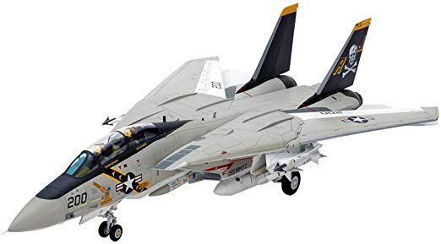 MIG 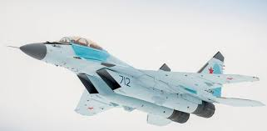

terrified = very scared; extremely frightened (81)
invade = to enter a place with the purpose of taking it over or stealing things (81)
maniacs = crazy people (81)
impolite = not well behaved; not having good manners; rude (82)
coup d’etat = the violent overthrow or taking over of a government by a small group (82)
condemned = found guilty of a crime (followed by prison or death or another punishment (82)
“the pits” = the worst; the lowest (83)
defeatist = expecting to lose; believing that you will be defeated (83)
national anthem = official song standing for love of and loyalty to your country (83)
cool = great; terrific; wonderful; outstanding (85)
totally = completely; definitely (85)
context = the situation in which something exists; the setting or environment (86)
impressed = had a positive, good effect (86)
console = to comfort; to soothe; to make a person feel better (86)
civilized = acting in a nice way to other people (87)
jerry cans = metal cans or containers used to hold liquid (88)
the press = newspapers, news magazines, news services (e.g. UPI, AP, Reuters) (88)
refinery = place where oil just out of the ground (called crude oil) is treated (called refined) to
become usable, as in gasoline and oil for cars (88)
flee = run away to be safe; escape (89(
“up in smoke” – to disappear; to vanish (90)
materialistic = cares a lot about money, cars, clothing and other things that can be bought (90)
marble = a type of stone used in making buildings and statues, often a mix of black, gray and
white (90)
Star Wars = title of a series of outer space movies set in a galaxy far, far away (91)
Darth Vador = the villain (bad guy) in some Star Wars movies (91)
Princess Leia = the main female character and a good character in some Star Wars movies (91)
bitter = always angry and mean (92)
kidney beans = a type of red or white beans to be eaten (92)
flatulence = the body process of expelling gas via the anal aperture, often accompanied by an
odious odoriferous and sometimes noisome rancidity (see context for a synonym) (92)
refugees = people coming from a dangerous to a safe place (92)
descended = arrived or showed up in large numbers (92)
prostituting = having sex to make money (93)
dignity = the quality of being or acting in a respectful way (93)
sluts = insulting word for women who have many sexual partners (93)
whores = insulting word for women who have sex easily with no emotional connection (93)
humiliating = embarrassing; shameful (93)
intolerable = something hard to accept or deal with or manage (93)
arms = weapons (94)
quality versus quantity = condition or situation compared to amount (94)
“reservoir of potential soldiers” = large number of men who can be made into soldiers to
fight in the war (94)
nuptial chambers = rooms for newly married brides and grooms (94)
carnal knowledge = the act of having sex (94)
philosophy = a belief or collection of ideas; a way of thinking (94)
resignation = accepting the way things are (94)
mourn = feel sorry or sad for a dead person; miss a person who recently died (95)
initiation = first experience; first time doing something (96)
“flower of our nation’s youth” = the best of our young people (96)
session = a period of time; meeting time (96)
rituals = customs; repeated ways of doing things in a nation’s, group’s or religion’s culture (96)
flagellated = whipped; hit over and over (96)
brutally = done in a painful, hurtful way (96)
anniversary = a celebration noting something special that happened a specific amount of time
in the past (a month ago, a year ago), such as a wedding anniversary (97)
garlands = decorations (often curved) put in different nearby places to celebrate (97)
worthless = having no value or use; a waste (97)
united = all together (97)
suspended = not allowed to go to classes for a period of time (like a week) (97)
rebellious = fighting against the person or group in charge (98)
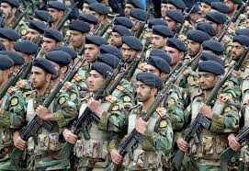
generation = a group of people close to the same age (98)
secular = not religious (98)
expelled = forced to leave a school and never come back (98)
opportunity = a chance to do something (98)
actually = really (98)
Some of the Iranian military
faithful = loyal; staying with (99)
paradise = heaven; a perfect and wonderful place to exist after death (100)
military = the army, navy and/or air force of a nation (101)
recruiting = getting people to join the military by showing them it’s good for them (101)
“the front” = the area where there is fighting in a war (101)
convince = to talk people into agreeing with you (101)
afterlife = the place and time people are found after life has ended (101)
trance = in a mental situation or condition in which you are aware of only one thing or
person, and in which you are not aware of where you are (101)
hypnotize = to put someone into a trance (101)
absolute carnage = total bloody disaster (from war or a big car or plane or train accident)
resulting in many deaths and injuries (101)

minefields = areas containing slightly buried hidden mines (bombs that explode and kill or
badly injure people if the mines are stepped on) (102)
fate = what will happen to you (102)
punk rock = loud, fast-moving music popular in the 19670’s and 1980’s (102)
shelter = a safe place; a place you can go to for protection (103)
instinctive = natural; not needing any thinking to figure out what to do (104)
“anxiety seized you” = feelings of worry controlled you; troubled emotions filled you (104)
interiors = insides (here, of buildings or rooms) (105)
regime = the government in charge (105)
Video-cassettes
glimpse = a quick look (105)
denounce = to say bad things about someone or an idea (105)
video-cassettes = video tapes that movies and TV shows were put on and played on TV sets or
cassette players (before DVD’s and streaming video were created) (105)
banned = not allowed; forbidden (105)
hefty = very big; very large; possibly, very heavy (105)
“in spite of” = not caring about; without being affected or emotionally moved by (106)
power outage = loss of electricity (and, therefore, light and power to run things) (106)
vintner=wine maker (106)
“crushed the grapes” = stepped on bunches of grapes in order to make wine (106)
wail = make a loud sound; shout; cry out (107)
maternal instinct = a mother’s natural feeling to protect and take good care of her baby (107)
alert = a notice or sound to get people to pay attention (108)
ID = a card or document showing who you are; ID stands for identification (108)
registration = a card or form showing that a car belongs to you (108)
Westernized= behaving or dressing like someone from Europe or the Americas (108)
trash = garbage; junk; a worthless person (108)
elderly = very old (person or people) (109)
heart condition = heart illness; weak heart (109)
diabetes = a dangerous disease caused by the body making little or no insulin (110)
urgent = must be done or treated right away (110)
stall = to put off doing something until later; to hesitate or procrastinate (110)
ideology = religious or political beliefs or ideas (110)
bills = money; cash (here, a bribe) (110)
“pick-me-up” = something that gives a person quick energy (like an energy drink full of
caffeine) (110)
chicken = a coward; someone who is too scared to do what is necessary (111)
neighborhood = buildings and stores near each other, and the people who live there (112)
repression = holding people from having freedom (112)
latter = the second of two things, people, cars, etc. (112)
tactics = methods; procedures; steps of action (113)
survive = stay alive and well (113)
dictator = tyrant; person who leads a government by force, not democratically (113)
guardian = a person who protects something or someone from harm (113)
settlement = a peace agreement (114)
reconstruction = rebuilding a place after it has been destroyed (114)
imposed = forced to happen (114)
conquer = to defeat; to beat or overcome; to take control over (115)
plunged = fell quickly and for a distance (115)
belligerent slogans = groups of words in favor of fighting a war (115)
gory imagery = bloody pictures or scenes (115)
inject = to put something into (115)
eventually = sooner or later, but it will happen (116)
avoided = not having done something; not having allowed something to happen (116)
exterminated = killed; wiped out (117)
systematically = one by one; done in a planned order (117)
grown-up = an adult (117)
persecuted = attacked unfairly because of your beliefs or the way you look (118)
stress = a feeling of worry and tension; nervousness (118)
invoked = referred to; listed; mentioned (118)
stubborn = must have something done his or her way and no other way (119)
blunt = honest; telling the truth as you see it, even if it hurts someone (119)
sensitive = aware of or seeing how something affects other people (119)
Red Crescent trucks = ambulances or first aid trucks with people and medicine to help hurt
people, such as in war or in an accident or a natural disaster, such as an earthquake or a hurricane. The Islamic Red Crescent is like the Red Cross in other countries. (120)
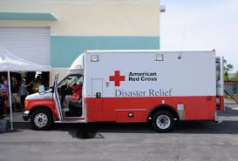
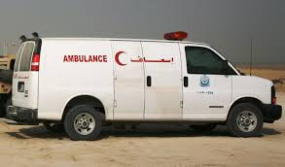
Red
Cross
Red
Crescent

wounded = hurt; injured (120)
embarrassed = feeling shame; feeling very upset with yourself in front of others (120)
grenade = a small explosive (like a bomb) thrown by hand (121)
permit = a paper document giving official permission or allowing someone to do something
(e.g. a driver’s permit) (121)
offending = upsetting; insulting; making someone feel bad (121)
authorization = official permission (okay) to do something or go somewhere (121)
pathetic = very sad; pitiful (121)
chemical weapons = killing weapons which are made of poisonous gas, not bullets or
bombs (122)
veritable = real; actual; not imaginary (122)
human guinea pigs = people who are experimented on to see if something works (122)
acquaintance = someone you know (123)
counter-revolutionary = against or opposed to the revolution and its ideas (123)
asylum = safety; a place or condition of protection from being hurt or harmed (123)
negotiating = bargaining for; haggling; coming to an agreement (124)
ransacked = looked through; searched and made a mess (125)
occupied Palestine = an area in the Middle East in which Palestinian Arabs live under the
control of the nation Israel (126)
unrecognizable = cannot be recognized or identified; one whose identity is changed (126)
uncool = not cool; not in style; someone who does not do things in a way acceptable to young
people (126)
hip = cool; in fashion; living in the latest way that modern young people like (126)
imports = things brought into your nation from other places to be sold to your people (126)
denim = a strong material (usually cotton) that clothing (pants, jackets) can be made of ( 126)
poster = a large sheet of paper advertising a performer or an event, such as a concert (126)
Kim Wade = an English singer popular with young people (1970’s – 1980’s) (126)
Iron Maiden = English heavy metal band, playing loud music (126)
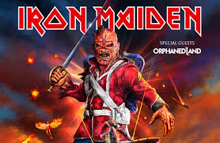
Istanbul = capital city of Turkey (was Constantinople) (127)
hypocrite = a person who says one thing and does the opposite (127)
enormous = very large (127)
stylish = modern-looking; wearing the latest-looking clothes (128)
Frankenstein = refers to a monster in a novel by that name; the monster
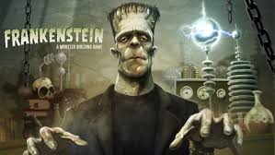
was made from parts of dead bodies sewn together
and brought to life by electricity; it moved in a way
that was unsteady, as if drunk (129)
model = type; style; design (130)
Michael Jackson = American popular singer (130)
“far out” = great; cool; very nice (130)
genius = an extremely smart person; highly intelligent (130)
Nikes = sneakers (made by the company Nike) (131)
permissible = allowable; can be allowed; not strict (131)
black market = (not an actual place) a way of selling things not allowed sold in stores (132)
complicated = not simple; having many parts or ideas (132)
Stevie Wonder, ABBA, Yazoo, Julio Iglesias, Pink Floyd, Camel = popular singers or singing
groups in the 1970’s and 1980’s (132)
“straight and narrow” = the accepted and correct way of doing things (133)
alternative = another choice; another way (133)
Malcolm X = Black American leader trying to get equal rights (civil rights) for African Americans
In the 1960’s (133)
shrank = became smaller (133)
detain = to keep someone from leaving; to hold someone back (134)
orphanage = a home for kids without parents (134)
miraculously = unbelievably; fantastically; thought to be impossible (134)
whoah = (not really a word) (just a sound like singing (134)
ballistic missiles = missiles (rocket-like things) that can go a long way quickly and use gravity
to land and carry bombs, even nuclear bombs, to destroy a target, such as
a city or any place where enemies are living and fighting (135)
fortune = a large amount of money (135)
exaggerate = to describe something in a way that makes it seem better or worse or larger or
smaller or more important than it really is (135)
symptom = a sign; something that shows a condition (135)
confirmation = proof that something is true (135)
optimism = a feeling that things will be fine (135)
skeptical = not believing; doubting; not accepting (135)
pessimism = a feeling that things will be terrible (opposite of “optimism”) (136)
deserted = left empty; abandoned (136)
fatalism = the belief that you cannot stop bad things (even death) from happening (137)
linked = connected to; joined with (137)
circumspect = very careful (137)
reinforced concrete = a very strong building material which is a mixture of cement and other
thing, including thin metal bars (137)
espadrilles = light shoes, with a top made of a strong cloth called canvas (138)
tumans = a type of Iranian money (as dollars in the U.S. or pounds in England) (138)
currency = types of money used in a nation (138)
euphoria = great happiness; a feeling of much joy (138)
trembling = shaking, often from being nervous or afraid (140)
nightmare = a scary, frightening, horrible dream (140)
Jewish Sabbath = the time from sundown Friday till sundown Saturday when religious Jews
Follow certain rules of what they are or are not allowed to do (141)
observant = religious; follows the rules and laws of a specific religion (141)
the Hilton = an expensive, fancy hotel (one of a number of hotels with the same name in
different nations (141)
discreetly = acting wisely or properly and carefully (142)
turquoise = a green-blue gemstone used in jewelry that is worn (142)
rebel = here, a person who does not follow rules (143)
aggressor = attacker; person who acts rather than waits for things to happen (143)
bureaucrats = officials; people who work for a department of the government and follow all
the rules very carefully and expect others to do the same (144)
imprisoned = put into jail or prison (144)
dowry = money or something valuable (a cow?) paid by a man or his family to the family of the
woman he is going to marry (It is a custom in some places.) (146)
virginity = the physical condition of one never having had sex with another person (146)
innocent = here, never having had sex (usually refers to a young girl) (146)
Austria = a European nation near Germany (147) – not to be confused with Australia
Vienna = the capital city of Austria (147)
independence = freedom (148)
miserable = very unhappy (148)
adore = love very much (148)
pretty = here, very; quite (149)
departure = leaving a place (150)
jasmine = a plant with flowers that smell nice (have an attractive aroma), often used in making
perfumes (150)
preach = here, tell someone what to do or how to behave (150)
cruelty = being very mean; hurting someone (150)
vengeance = getting revenge; hurting someone who hurt you first (150)
bear = to put up with or manage, even if you have to suffer or be hurt (physically or
emotionally); to deal with (153)
suitcase = a usually rectangular container (with a handle and often with wheels) that holds
clothing and other personal items (e.g. toiletries) and used by one who travels
(153)
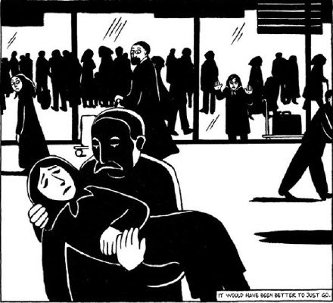

Why does Marjane’s mother
faint?

COMING ATTRACTIONS
