The meanings show the way the words are used in this book.
VOCABULARY
WORDS from
They Called Us
Enemy
by
George Takei
See p. 189
NOTE – You will know some of these words already, so use this list to see meanings of words you do not know. The page number where you can find a word or phrase is shown at the end of the meaning, in parenthesis, like this: (16).
Below are George Takei (far right) with his parents, Fumiko Emily and Takekuma, and his younger siblings, Henry and Nancy, following their internment.

1. enemy – a person who feels anger or hate toward another; opponent (Title)
2. executive order – an order that comes from the government (6)
3. “burned into my memory” – I will never forget it (idiom) (9)
4. starship Enterprise – a spaceship in the 1960’s TV show and movies called “Star Trek” (10)
5. soar – fly high (10)
6. galaxy – a large system of stars, planets, moons, asteroids (10)
7. mission – purpose; goal (10)
8. explore – to search an area looking to discover things (10)
9. explosion – a loud breaking apart (10)
10. target (verb) – to aim at (10)
11. fire (verb) – to shoot (10)
12. boldly – bravely; unafraid (11)
The Enterprise from “Star Trek”
13. seeking – looking for (11)
14. opportunities – chances for success in business and home life (11)
15. Bay area – San Francisco, California and nearby places (11)
16. pursued - went after (11)
17. lucrative – money-making; profitable (11)
18. corridor – a strip of land with many people living there (11)
19. traditionally Japanese – done according to Japanese customs and traditions; done the way
people living in Japan would do things (11)
20. school segregation – having separate schools for Japanese, Chinese, black and white
students because of racism (11)
21. celebrated – shared a good time; showed respect and caring for (12)
22. joyous – very happy (12)
23. precious – special; valuable (12)
24. befitting – showing; matching; suitable (a good choice) (12)
25. Anglophile – someone who loves everything and everyone from England (12)
26. Prime Minister, King – leader (12)
27. King George VI – ruled England/ British Commonwealth from 1936 to 1952; father of
Queen Elizabeth II (12)
28. (King) Henry VIII – ruled England / British Commonwealth from 1509 to 1547; father of
Queen Elizabeth I (13)
29. gracious – showing kindness and good manners (13)
30. “Silent Night, Holy Night” – words from a Christmas song called “Silent Night” (14)
31. interrupt – break into whatever is being said or broadcast on radio or TV (14)
32. Pearl Harbor – a large naval base (home to sailors and ships) in Hawaii (14)
33. counter-attack – fighting back against people who attacked first (15)
34. hostilities – war-like actions (15)
35. declaration – stating that a war has begun (15)
36. temper – mood (15)
37. granted – approved; okayed (15)
38. conviction – belief (16)
39. “cast the die” – made up its mind about what it will do (here, it = Japan) (idiom) (16)
40. confusion – not knowing what to do (16)
41. hysteria – panic; losing control of emotions such as fear or anger (16)
42. Eleanor Roosevelt – wife of President Franklin Delano Roosevelt (FDR) (16)
43. convening – having a formal meeting (16)
44. proclamation – an official announcement from people in charge (16)
45. alien – foreign (16)
46. strict regulations – rules that must be followed or obeyed (16)
47. transmitting – broadcasting; sending out information on a radio or TV (16)
48. codes, ciphers – secret messages (16)
49. invisible writing – writing that cannot be seen until a chemical is put onto the paper (16)
50. sketch – a rough (not finished) drawing of a person, object or place (16)
51. graphical representation – a chart, table, graph, diagram, design that shows information (16)
52. naval installations – bases or camps that house sailors, ships, submarines, etc. (16)
53. ammunition – explosive military items, such as bombs, grenades and bullets (16)
54. implements of war – things used in the fighting of a war (weapons, tanks, jeeps, etc.) (16)
55. device – a piece of equipment; something made for a specific purpose (16)
56. “in violation of” – breaking a rule; doing something not allowed (16)
57. foregoing – already mentioned or written about (16)
58. “subject to seizure and forfeiture” – can be taken away from you and not returned (16)
59. undertake – to take action; to act; to do (16)
60. ascend – to go up or fly upward (16)
61. commercially – owned by a company that makes money (16)
62. privately – owned by a rich person or group for personal use (16)
63. prescribe – to order to be done (16)
64. infamy – fame for doing something bad or wrong (17)
65. deliberately – done on purpose; intentional; not by accident (17)
66. severely – greatly; largely (17)
67. implications – suggestions; how ideas have to do with each other (17)
68. directed – ordered (17)
69. onslaught – attack (18)
70. overcome – win against (18)
71. premeditated invasion – a planned attack against another nation (18)
72. buzzcut - a very short haircut for men (18)
A buzzcut:
73. righteous – justified; acting properly and correctly (18)
74. absolute – total; complete (18)
75. hostilities – fights; conflicts; battles (18)
76. “no blinking” – denying; refusing to accept the truth (idiom) (18)
77. grave – serious (18)
78. confidence – trust; belief in (18)
79. unbounding – total; complete (18)
80. “inevitable triumph” – victory that will definitely happen; a win that must come (18)
81. unprovoked – had no cause; done with no good reason [against an innocent nation that
did nothing to make another nation attack it] (19)
82. dastardly – cowardly; done by cowards or people who weren’t brave; done in a sneaky
way (19)
83. intended – on purpose; did what you meant to do (19)
84. “lock up the Japs” – put Japanese-Americans into jails or prison camps (20)
85. Achilles heel – weakest part or weakest place (20)
86. repetition – the act of repeating; doing the same act over and over (20)
87. attorney general – the main lawyer who represents a government against criminals (20)
88. division – separating of people or groups (20)
89. rhetoric – speaking; way of talking; words you choose when you speak or write (20)
90. sabotage – destroying the enemies’ property or doing things to make it harder for enemies
to succeed during a war (21)
91. “fifth column activities” – here, a group of Americans working secretly against the success
of the United States in its war against Japan during WW II (idiom) (21)
92. ominous – a bad sad; a warning sign (21)
93. inscrutable – impossible to understand; puzzling; hard (didfficult) to figure out (21)
94. prudent – wise; smart (21)
95. evidence – proof; showing that something happened (21)
96. Chief Justice – the leader of the Supreme Court, the highest court in the U. S. (21)
97. nonassimilable - not able to become citizens of the U. S. because they refuse to follow the
customs, laws and ways of doing things that Americans practice (21)
98. generation – people of a similar age group (21)
99. intend – mean to; want to (21)
100. loyal – patriotic or faithful or devoted [to the U. S.] (21)
101. “blood will tell” – people of a certain race or background (ex. with Japanese ancestors)
will always act the same way . . . in this case, the way people living in Japan would act (idiom) (21)
102. episode – event; happening (21)
103. executive order – See Definition 2 (22)
104. excluded – not allowed; not permitted (22)
105. accommodations – places and things necessary to live (22)
106. civilian – not military; not to do with the army, navy air force, marines, coast guard (23)
107. district – an area; a location (23)
108. designated – assigned; noted (23)
109. landmark – a well-known place; a famous place (23)
110. processing – going through a group of necessary steps or moves (23)
111. possessions – those things you own (ex. furniture, clothing, jewelry) (23)
112. “freezing … bank accounts and financial assets” – not allowing people to take out any
money they have in banks or to sell their stocks or bonds or homes or land (24)
113. estates – all property owned (ex. land, houses, furniture, jewelry) (25)
114. “a fraction of its worth” – very little of its total value (ex. getting 10 cents for every dollar
that something is worth, so for a house worth $100,000, you’d get $10,000) (25)
115. “Evacuation Sale” – a forced selling of property and furniture because a family must
move out by order of the government and leave most of what they own behind (25)
116. relocation – moving to another place or location (25)
117. saboteurs – people who commit sabotage (see Definition 90) (25)
118. harvest time – the time when vegetables that you have grown are taken to eat or be sold (25)
119. not sympathetic – not caring about how you feel (25)
120. considerable – a large amount or number (25)
121. “at great sacrifice” – for very little money (not for what they are worth) (idiom) (25)
122. investigate – examine; study (25)
123. widespread – in large numbers; involving or concerning many people (25)
124. “your account has been frozen” – See Definition 112 (25)
125. targeting – See Definition 10 (26)
126. evacuation – large numbers of people leaving an area, either voluntarily or forced (26)
127 curfew – an announced time after which nobody is allowed on streets except police or
military (26)
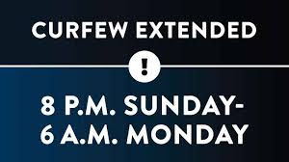
128. intended – See Definition 83 (26)
129. fifth column – See Definition 91 (26)
130. commander – person in charge; person in control (26)
131. hysteria – See Definition 41 (26)
132. disloyal – not doing the right things for your country, friend, etc. (26)
133. rigid – strict; tough; unchanging (26)
134 regulations – rules (26)
135. violators – people who break the rules (26)
136. military necessity – what is required by the military; what must be done (26)
137. enforcement – actions needed to make people follow the rules (26)
138. duty – responsibility; required way of behaving (26)
139. urged – strongly asked (26)
140. authorities – people in charge; people who make the rules (26)
141. swiftly – quickly (27)
142. imprisonment – put into prison or jail; incarcerated (27)
143. deliberately – See Definition 65 (27)
144. unconstitutional regulations – rules or laws that are not allowed in the U. S. Constitution,
the most important set of laws in the U. S. (27)
145. residence – place where you live (27)
146. posters – signs (27)
147. birthplace – where someone (usually famous) was born (28)
148. final resting place – location of his or her grave (28)
149. FDR – President Franklin Delano Roosevelt, president of the U.S. from 1933 to 1945 (28)
150. Presidential Library – a library containing books by and about a President, together with
many important documents and photographs and films / videos showing the President
before and while and after he was President (28)
151. Day of Remembrance – a special day when an important event is remembered (28)
152. symbolic – having a special meaning (29)
153. full house – a large crowd, with no empty seats (29)
154. parkway – a highway on which cars drive and where no trucks are allowed (29)
155. amidst – in the middle of; among (29)
156. steeped in lore – in the middle of famous [true] stories from history (29)
157. unloaded – taken off the trains (31)
158. Santa Anita Racetrack – a place in California where horses race (31)
159. herded – moved crowded together like sheep or cows (31)
160. stables – places where horses are housed, to be fed and washed and to rest (31)
161. pungent – a sweet and sour smell or taste (32)
162. manure – waste matter (doodoo) that comes out of a horse’s rear end (32)
163. grasp – understand (32)
164. injustice – unfairness; an act that is not fair (32)
165. devastating blow – painful effect on your emotions (32)
166. stall - a small area in a barn in which a horse is kept (32)
167. degrading – making a person feel as if he/she is not very important (32)
168. humiliating – unfair treatment that is embarrassing and not deserved (32)
169. painful – here, emotionally hurtful (not physically) (32)
170. unsanitary – unclean and unhealthy (33)
171. paddocks – gated or fenced areas used for exercise or walking around, eating grass (33)
172. dispensed – given (33)
173. tending to – taking care of (33)
174. settle into – get used to (34)
175. normalcy – a time in which everything is normal or the way it usually is (34)
176. unrest – a time when people are upset or angry or nervous and show how they feel (34)
177. fester – develop; show itself [getting worse] (34)
178. grandstand – a section of a stadium or arena which contains rows of bench-like seats (34)
179. arrivals – people who arrive; people who get to a place (35)
180. “luxury” – Since the word is in quotation marks, it means the opposite: a poor place to
live, with hardly any furniture and nothing comfortable. (35)
181. barracks – a set of rooms very close together; a dormitory, as in college (35)
182. residence – See Definition 145 (35)
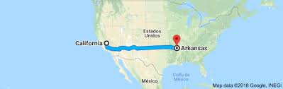
183. single file – one person at a time in a line (36)
184. departs – leaves (36)
185. tagged – made to wear name tags with other data (36)
186. cattle – a group (herd) of cows (36)
187. retained – kept; held onto (36)
188. de-humanizing act – done to make someone feel less than a human being (36)
189. assumed – believed; accepted (36)
190. criminals – people who have broken the law and committed crimes; crooks (37)
191. hack, koff – the sounds of people coughing (onomatopoeias) (37)
192. vacation – a time during which one goes from home and enjoys oneself (38)
193. Arkansas – a Southern state near the Mississippi River, touching the states of Mississippi
and Tennessee, and about 1,803 miles from California, where Takei lived (38)
194. armed sentries – guards who had guns (39)
195. approach – come close to (40)
196. shade – window covering to keep sunlight out of a room or train car (40)
197. innocent children – children not aware of what was really happening (40)
198. comprehend – understand (40)
199. in the middle of nowhere – not any place close to a town or city or village (42)
200. lively – full of energy; very active (43)
201. in command of – in charge of; in control of (44)
202. venturing – moving with exciting feelings (44)
203. anguish – mental pain; hurtful thoughts (45)
204. torturous – causing pain (45)
205. incarceration, internment – imprisonment (See Definition 142); placed in a type of jail
or fenced-in area from which you are not allowed to leave (45)
206. “noble, shining ideals” -great ideas of making lives almost perfect (45)
206. fallible – with faults; not perfect; with bad qualities or doing bad things (45)
207. - {shows that someone is singing} (46)
208. giggle – laugh (46)
209. break’s – time is (46)
210. ya – you {shows how someone pronounces the word in his way of talking} (47)
211. kiddo – slang word for “kid” or “child” (47)
212. offered – gave (48)
213. canteens – small containers (holding a drink) (48)
214. sips – small amounts of a drink (48)
215. lukewarm – warm; neither hot nor cold, but in between (48)
216. periodically treated to – given once in a while; given occasionally (48)
217. In actuality – Really; In truth (48)
218. obsessive concern – great worry (48)
219. well-being – good health (48)
220. boredom – the noun form of “bored” (49)
221. foe – here, a condition or feeling that keeps someone from being happy (49)
222. determined to fight – decided to not allow (49)
223. glowing recollections – wonderful memories (49)
224. goodies - good and enjoyable things (ex. candy, toys, comic books) (49)
225. selflessly – done for someone else (opposite of “selfishly” which means “done only for
yourself”) (49)
225. limited luggage – small number of suitcases and bags allowed (49)
226. starkly – completely; clearly; obviously (49)
227. anxiety-ridden voyage – a trip in which a person’s mind is filled with worries (49)
228. unknown – not knowing what will happen (49)
229. preoccupied – busy thinking about something else (50)
230. unwilling to surrender – refusing to give up (50)
231. anguish – See Definition 203 (50)
232. motion sickness – a bad (nauseous) feeling in the stomach when one travels (50)
233. obsessive concern – See Definition 218 (50)
234. melancholy – large amount of sadness (50)
235. dusty, peripheral remembrances - old, almost lost memories (50)
236. dependable – reliable; can be counted on [as good] (50)
237. deceptive – tricky; seeming to be good but turning out to be bad (50)
238. slippery – not dependable; changing too easily from real (51)
239. misrendering – not representing; not showing (51)
240. out of context – not placed in what was really happening at the time (51)
241. intensely subjective – very much according to the way you remember it, not really as it
really happened (not showing what was really going on) (51)
242. haunted by – bothered or disturbed by the memory of (51)
243. vaguely – unclearly (51)
244. circumstances surrounding my childhood – things going on when I was very young (51)
245. desert – large area covered with sand (52)
246. “You know the drill” – “You know what to do” (52)
247. Screeee, Hissss, Clang, Scraape – sounds that the train is making (onomatopoeias) (52)
248. Fwap! – the sound of a window shade being pulled down quickly (onomatopoeia) (53)
249. K-Chung – the sound of the train wheels moving along the tracks (onomatopoeia) (54)
250. “Land of Opportunity” -ironic motto of the state of Arkansas: There is NO opportunity
or chance for a wonderfully improved life for the Japanese-Americans there. (54)
251. Rohwer Relocation Center (Camp Rohwer) – name of the internment camp where the
author and his family would be kept prisoner during the war (Note that the names of
all 10 internment camps and their locations are shown on the U. S. map) (55)
252. Imai-san – a new place to live (55)
253. North Hollywood – a place in California with a lot of homes (55)
254. Block 6, Barrack 2, Unit F – {the exact place where the Takei family would be living} (57):
See the picture of the place on p. 58.
255. peak – when it had the most people (58)
256. located – placed; found (59)
257. Ca-Caw – the sound that a bird might make (onomatopoeia) (59)
258. dinosaur- giant lizard animals from hundreds of thousands of years ago
(ex. Tyrannosaurus Rex [in the picture], Triceratops, Velociraptor, Haplocheirus) (60)
259. cabin – a very small home -- here, containing only one room (63)
260. furnace – a machine that produces / makes heat (63)
261. pant – the sound of breathing hard (64)
262. heavy and boiling – thick, very humid, full of moisture, very hot air (65)
263. distributing – giving out (66)
264. army cots – simple folding beds with a cloth mattress (66)
265. “Don’t mention it” – “There is no need to thank me” (idiom) (66)
266. privacy – being able to keep others from knowing what you say and do (66)
267. “It can’t be helped” – “We can’t do anything about it” (idiom) (67)
268. treat – something good; something that gives pleasure / good feelings (67)
269. forbidden – not allowed; not permitted (68, 69)
270. sewing machine – a machine that is used to help make clothing by stitching parts of the
clothing together (69)
271. heavy, crushing disappointment – the opposite of what you expected; no fun at all (69)
272. priority – most important (70)
273. rough-hewn – newly cut; not finished; not sanded and painted (70)
274. curtains – material window coverings (70)
275. surplus fabrics – extra materials or cloths (70)
276. strips – long, thinly shaped (70)
a braided floor mat
276. discarded rags - material that has been thrown away (70)
277. braided – made by putting together different long sections [of material or hair] (70)
278. floor mat – a floor covering like a rug to walk on (70)
279. relief – feeling of less stress (71)
280. aspect – side; part (71)
281. denied – not allowed to have (71)
282. comforting – making people feel more relaxed and comfortable and taken care of (71)
283. statement of defiance – way of showing that you refuse to accept being controlled (71)
284. tortured – made to feel pain (72)
285. anguish – See Definition 203 (72)
286. community – a group of people living near each other and spending time together (72)
287. outset – beginning; start (73)
288. acquainted with – familiar with; getting to know about (73)
289. Buddhist minister – a leader of the religion of Buddhism (73)
290. federal agents – like the police, officers of the U. S. government, such as FBI agents (74)
291. committed – did (74)
292. formal charges - official laws that were broken or ignored (74)
293. occupied highly visible positions – had jobs that were important to the community (74)
294. issei, nisei and sansei – See definitions on p. 75.
295. professionals – jobs that require advanced education (ex. lawyers, doctors, teachers) (76)
296. common denominator – something we share; something the same about us (idiom) (76)
297. keenly – strongly; powerfully; sharply (76)
298. forge -make; build (76)
299. swamps – muddy, very soft and wet land (77)
300. with force – strongly; heavily; with power (77)
301. latrine – toilet; bathroom (77)
302.secured – tight; cannot be moved (77)
303. mess hall – cafeteria; eating place; dining area (77)
304. scraps – pieces (77)
305. boardwalk – a sidewalk made of wood (77)
306. “It was no work of art” – “It was ugly”; “It was not nice to look at” (idiom) (77)
307. navigating – moving over; walking over (77)
308. messy – sloppy; not nice to look at; ugly (77)
A messy room:
309. unacceptable – not good enough to accept; not good (78)
310. inevitable – will definitely happen; cannot be stopped (78)
311. privacy – See Definition 266 (78)
312. cropping up – appearing; showing up (78)
313. representative – a person who speaks for (represents) (78)
314. community – See Definition 286 (78)
315. uniquely qualified – the only person who has the skills to speak for (78)
316. task – job; work to be done (79)
317. fluently – completely (as in to know a language without having to think about which
words or idioms to use) (79)
318. directly – honestly and personally to (79)
319. bridged the gap – could speak with two different [age] groups well (idiom) (79)
320. elders – leaders who were the oldest and wisest and most experienced people (79)
321. credibility – will be believed and trusted (79)
322. acutely – sharply; deeply; accurately; clearly (79)
323. willingly - without being forced to do something (79)
324. block manager – person who stands for people living in a group of homes (79)
325. manage his workload – control and finish the work he had to do m(80)
326. resolved -solved; completed; figured out; finished (80)
327. involved in all manner of bureaucracy – dealing with or handling many documents that
had to do with getting things done and communicating with the people in charge (80)
328. pressing – urgent; needing immediate attention (80
329. astounded – amazed; very surprised (80)
330. a mile a minute – very quickly (idiom) (80)
331. establishing – setting up; beginning (81)
332. cowards – people who are so afraid that they will not do something necessary (82)
333. gotcha – slang (not good English) word meaning “I’ve got you” (82)
334. cowboys and Indians – enemies fighting each other (as shown in old movies) (82)
335. magic word – a secret word that can make thing happen (83)
336. guards in the tower – soldiers in high places with guns guarding the Japanese-Americans
to keep them from leaving the internment camp (See the picture on p. 84) (83)
337. soldiers with rifles – military men with guns (84)
338. goodies – See Definition 224. (84)
339. run like hell – run very quickly (idiom) (87)
blowing a bubble:
340. coward – See Definition 332. (87)
341. bubble gum – gum which you can chew and blow bubbles with (87)
342. popsicle – an ice pop; sweet flavored ice on a stick (87)
343. tricycle – a type of bicycle with three wheels for small children (88)
344. hrmpf – the sound made when you take a deep breath (inhale a lot) (onomatopoeia) (88)
345. little snot – wise guy; nasty little boy (89)
346. Oh! Oh!, Hehehe – the sounds of people laughing (onomatopoeia) (89)
347. solve the riddle – figure it out; get the answer to a hard to understand question (90)
348. son of a bitch – a curse phrase (not nice to call someone); n insult (91)
349. outing – a short vacation; going outside where we usually go (92)
a military Jeep:
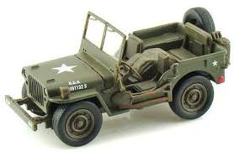
350. jeep – in the 1940’s, a car used by soldiers which was good driven
on rough roads, and even where there were no roads: the name
“Jeep” comes from the letters “General Purpose [car]” or GP. (92)
351. seemed like forever – seemed to take a long time (idiom) (92)
352. block manager – See Definition 324. (92)
353. Chnnngg – the sound of a gate opening (onomatopoeia) (95)
354. Grrnnn – the sound of the jeep driving away (onomatopoeia) (95)
355. Whoa – a word you say when you want something, such as the wind, to stop (96)
356. Screee…chk – the sound that the tires make when a car stops suddenly (onomatopoeia) (97)
357. snort; grunt – sounds made (onomatopoeia) by a hog (a very large pig) (98)
358. Spam – a canned cooked meat product made from ham, salt, water,
modified potato starch (as a binder), sugar, and sodium nitrite
(as a preservative). The letters in SPAM stand for Special Processed
American Meat. (It is an acronym.) (98)
359. put some hair on your chest – will make you strong and full of energy
(idiom) (98)
360. Vroooom – sound of the engine of a car moving quickly (onomatopoeia) (99)
361. was determined – made up her mind; was going to act that way (100)
362. rich with sensations – full of memories of sights, sounds, smells, tastes (100)
363. fragrances – pleasant (enjoyable) smells (100)
364. especially – very much; more than anything else (100)
365. golden afternoon – beautiful, sunny afternoon (100)
366. a fond memory – something you remember with good feelings (100)
367. glows radiantly with warmth – shines with happy feelings (100)
368. experiencing – feeling and seeing; going through (101)
369. beyond words – so great that it is impossible to describe how you feel (idiom) (101)
370. pure – total; 100%; complete (101)
371. chilly – cold (102)
372. retain warm memories – keep memories that fill me with good feelings (102)
373. spread – passed from child to child so that everyone heard about it (103)
374. reindeer and sleigh – the way Santa Claus is supposed to travel
Santa, his sleigh &reindeer:
on Christmas Eve (103)
375. cleaned my plate – ate everything that was on my plate (104)
376. reasoned – figured out; thought (104)
377. bellies – stomachs (105)
378. Saint Nick – Saint Nicholas, another name for Santa Claus (105)
379. off – not right; not correct (107)
380. suspicions – reasons not to believe something or someone (107)
381. break the illusion – ruin or upset or destroy the idea of what was happening (107)
382. dead giveaway – definite clue / hint about something not being true or real (107)
383. spoil – ruin; mess up (108)
384. barbed-wire fence a fence (type of wall) with sharp wire knots on it to stop people from
See the picture below:
climbing over it because they would be hurt (108)
385. figured – thought; decided (108)
386. fake – not real (108)
387. merrier – happier (108)
388. discovery – finding; something learned before other people have learned it (108)
389. recollections – memories; things you remember (108)
390. unfortunately – sadly (108)
391. joyous – happy (108)
392. outrageous – very upsetting; very disturbing; unbelievably bad (109)
393. allegiance to emperor – loyalty or willingness to follow and obey the leader [of Japan] (109)
394. grown-up – adult; concerning those older than childhood and teenage years (110)
395. loyalty – feeling that you want to do things to help your country (111)
396. constantly under suspicion – not trusted all the time (111)
397. theater of operation – area where military action (battles; attacks) take place (111)
398. theoretically – possibly but not definitely; adjective form of “theory” (111)
399. assimilated – become part of American society, doing things and thinking like an
American (111)
400. stab you in the back – hurt you in a sneaky way because he cannot be trusted (idiom) (111)
401. register – to sign up; to record your name and become part of an official list (here, as a
person who is ready to join the military and fight for the U. S. in a war) (111)
402. military service – to serve in the army, navy, air force (which was part of the army and
navy at that time), marines, coast guard (111)
403. patriotism – a feeling of wanting to be loyal, faithful to your country (111)
404. a slap in the face – an insult; a refusing to be accepted (111)
405. denied - See Definition 281. (111)
406. categorized – put into a group or class (111)
407. 4C: enemy aliens – the group that was not allowed to fight for the U.S. because those
people were considered to be enemies of the U.S. and from Japan (111)
408. surrender – give up; hand in (112)
409. out for – on (112)
410. set foot in – visited; walked on the land of (idiom) (112)
411. presumed – believed without any good reason or proof (112)
412. racial loyalty – loyalty (See Definition 395) to their race (Japan) (112)
413. infuriating – made very angry (112)
414. had a high cost – many soldiers and sailors were killed (idiom) (113)
415. denied – See definition 281 (113)
416. right to exercise the responsibilities of citizenship – here, the right to fight for the U.S. (113)
417. regardless of ancestry – no matter where your family came from (113)
418. represented – stood for; was (113)
419. war relocation authority – the government group in control of moving people to the
internment camps ((prison camps for Japanese-Americans) (114)
420. mandatory – must be done; ordered to do (114)
421. questionnaires – papers with many questions you must answer about yourself (114)
422. membership in organizations – groups, such as clubs, that you belong to (114)
423. foreign investments – money you have put into companies in countries outside the U.S.,
in order to make more money (114)
424. infamous – the adjective form of Definition 64 (114)
425. combat duty – being part of shooting and being shot at in a war (114)
426. swear unqualified allegiance – promise total loyalty (See Definition 395) (114)
427. faithfully – completely and honestly (114)
428. foreign or domestic forces – fighters from the U.S. (domestic) or other nations (foreign) (114)
429. forswear – refuse; not allow (114)
430. allegiance – See Definition 393.
431. obedience – obeying; following the orders of (114)
432. outrage – great upset; large insult; very hurt feelings (115)
433. dubious label – unpleasant name; less than respectful title (115)
434. pledge – promise (115)
435. upended – totally messed up; took our comfortable and happy lives away (115)
436. rested on a false premise – depended on a wrong idea (115)
437. response – answer; reply (115)
438. justify – show the correctness of; explain why it is right (115)
439. enemy aliens – See Definition 407. (115)
440. Asian immigrants – people coming from Asia to become citizens of the U.S. (116)
441. forbidden – See Definition 269. (116)
442. rejected – refused to accept (116)
443. ethnicity – here, your background (such as Japanese, Chinese, Mexican, Colombian) (116)
444. discard – throw away (as in Definition 276) (116)
445. heritage – See how it is defined on this page (116)
446. stateless – not belonging to any nation in the world (116)
447. absurd - ridiculous; stupid and silly and hard to believe (116)
448. frustration – a feeling that you have tried very hard but cannot do something right (116)
449. outrageous – See Definition 392. (117)
450. bit the bullet – did not fight or argue back; just accepted the pain (idiom) (117)
451. swallowed the bitter taste – accepted the bad situation or condition (idiom) (117)
452. regimental combat team – a large group of soldiers who will be fighting the soldiers from
the enemy side (in this case, the Japanese-American soldiers would be fighting the
Nazis and other enemies of the Allies (U.S., England, etc.) in Europe) (117)
453. surrounded – soldiers from the side they were fighting were all around them (118)
454. patrolling – walking around and guarding or protecting, looking for enemies (118)
455. previous – came before; happened already (118)
456. “Lost Battalion” – group of soldiers whose location nobody knows (Where are they?) (118)
457. segregated – kept apart from other races of U.S. soldiers (118)
458. break through German lines – attack and defeat German soldiers (118)
459. intense – very heavy; a large amount; here, a lot of shooting (119)
460. rescue – save from harm (119)
461. casualties – soldiers killed or injured (wounded) (119)
462. Bavaria – southeastern Germany (an area including the city of Munich) (119)
463. POW – Prisoner of War; soldier captured by enemy soldiers and help prisoner (119)
464. liberated – freed; made free; taken from the enemy soldiers (119)
465. sacrificed – did without [safety, better lives] (119)
466. decorated – given medals for bravery in fighting (battle) (120)
467. President Truman – U.S. President from 1945 to 1953 (120)
468. Distinguished Service Cross – the second most important medal given for great bravery
while being shot at (120)
469. prejudice – being treated as not important because of unfair feelings against the group
that you are part of (ex. racism, sexism, ageism, homophobia; misogyny); bias (120)
470. awarded – given or presented for doing something great (120)
471. incredible – unbelievable; outstanding (120)
472. Congressional Medal of Honor – the highest military medal given for greatest bravery (120)
473. unrepayable -such a great act that it is impossible to pay for (120)
Medals of Honor:
474. President Clinton – U.S. President from 1993 to 2001 (120)
475. appointed – named (120)
476. commission – a committee or group given a specific (exact) job (120)
477. ceremony – a special gathering to honor a person or group (120)
478. surviving members – people still alive (120)
479. veteran – a former soldier or sailor or military aviator (121)
480. sponsored a bill – made and tried to get an idea passed into law (121)
481. instructed – ordered (121)
482. review – go over [the circumstances of or reasons for] (121)
483. determine – find out; decide (121)
484. unfairly denied – refused without a good reason (121)
485. recognition – honor; understanding of how brave they were (121)
486. well-served – served properly and correctly, with honor (121)
487. ill-treated – treated unfairly; treated poorly; not shown respect they deserved (121)
488. clung – held onto (121)
489. ideals – See Entry 206. (121)
490. stance on the issue – position and opinion on the subject being discussed (122)
491. hometown – where you lived before being moved to an internment camp (122)
492. draft board – the committee or group of older Americans who decided which people
would be drafted (have to go into) the army (122)
493. sentries – guards (122)
494. towers – See Definition 336. (122)
495. principled objectors – people whose ideals (See Definition 206) would not allow them to
do what they were ordered to do (122)
496. transferred – moved from one place to a different place (122)
497. penitentiary – prison (122)
A battlefield:
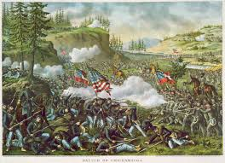
498. heroic – acting bravely (122)
499. battlefields – places where fights (battles) happened (122)
500. responded – answered; replied (123)
501. principles – beliefs; ideals (See Definition 206.) (123)
502. courage - bravery; refusing to let fear control them (123)
503. choices – those things you choose to do; selections (123)
504. demonstrate – show (123)
505. patriotism – See Definition 403. (123)
506. rejected – See Definition 442. (123)
507. relocated – moved to another place of internment (imprisonment) (124)
508. fateful – caused their fate; made happen what was done to them (124)
509. terrified – greatly scared; very much frightened (125)
510. part of the landscape – something you lived near that you accepted as normal (idiom) (125)
511. platform – place from which you step onto a train (125)
512. unbearable – very hard to accept or handle (125)
513. converted – changed (126)
514. maximum-security – has the greatest number of well-armed soldiers to guard those
thought to be the most dangerous prisoners (126)
515. segregation – See Definition 20. (126)
516. disloyals – those who are against the U. S. way of life (126)
517. battle-ready troops – soldiers who are trained, armed and ready to fight in a war (126)
a tank:
518. machine-gun – a type of gun that shoots many bullets very quickly (126)
519. tanks – trucks that are covered with heavy metal armor and have guns (126)
520. minority - a small number; less than 50% (127)
521. repatriation – in this case, to be sent to Japan rather than be in a prison (127)
522. war-torn – with bombed buildings and other damage from war (127)
523. outrage – See Definition 392. (127)
524. hysteria – See Definition 41. (127)
525. notorious – famous for doing something terrible; infamous (See Definitions 424 and 64.) (127)
526. At its peak – when it held the largest number of people (127)
527. heavily militarized facility – a place where there were many soldiers and many guns (127)
528. internees – Japanese-Americans being held as prisoners who could not leave (127)
529. cot – See Definition 264. (128)
potbelly stove
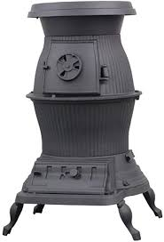
530. converted - changed into (128)
531. sofa – couch (128)
532. potbelly stove – a stove that has a large round part where the fire is (128)
533. afforded – gave (128)
534. linoleum – a floor covering made from material similar to a type of plastic (128)
535. stink – has a terrible smell; smelly (129)
536. got on … nerves – made a person nervous; bothered someone (idiom) (129)
537. bitterly – angrily; showing a lot of anger (129)
538. wafted over – floated over, went through the air over (129)
539. trade-offs – things you get in place of things you give or give up or cannot have (130)
540. collected – gathered; got together (130)
541. “Why was I not made of Stone like thee” – words coming from the movie they are
watching (131)
542. “I’m not a man! I’m not a beast! . . . moon!” – more words from the movie (131)
543. power – ability [of movies] to move you from where you are, in your mind (131)
544. Charles Laughton – an English actor famous in the 1940’s (131)
545. The Hunchback of Notre Dame – name of the movie they are watching (131)
546. vividly – clearly; in great detail (131)
547. empathized – understood someone else’s feelings (131)
548. love-starved – wanting to be loved very much (131)
549. scorned – rejected; not accepted; not treated as someone you could love (131)
550. transporting experience – making you feel as if you were in another time and place (131)
551. old Paris – This movie, The Hunchback of Notre Dame, takes place in 15th century Paris (131)
552. fascinating – very interesting; charming; holding your interest (131)
553. fall in battle – killed while fighting in a war (131)
554. soul is honored – spirit will be held in high respect by his ancestors and his relatives (131)
555. audio track – the sound of a movie (131)
556. benshi – a Japanese performer who narrated (talked about, explained) silent films (132)
557. shining mountain – handsome man (dialog from the movie they’re watching) (132)
558. mesmerized – hypnotized; put into a trance; giving all my attention to (132)
559. artist – here, not a painter or musician but an actor (132)
560. talented – having skills; able to do some things very well (132)
561. presently – right now (133)
562. disillusioned – no longer believing in something (134)
563. unrelenting series of abuses – unending bunch of insults or emotional hurts (134)
564. betrayed – lied to; fooled; turned against (134)
565. radicalized – now believe in ideas that are dangerous and can cause harm (134)
566. disloyal Japs – Japanese-Americans who are against the U.S. (135)
567. lumped in – put into a group (135)
568. genuine – real; true (135)
569. aligned – joined; had to do with (135)
570. raided – attacked (135)
571. suspected – thought of as (but without proof); considered (135)
572. arrested innocent people – put people into jails who did not belong there (135)
573. barred – prevented; not allowed (136)
574. dismissed – sent home (136)
575. until further notice – until you are told differently (136)
576. fuel – oil; gasoline (136)
577. sporadic – occasional; once in a while; not at regular times (136)
578. informants – spies; people who tell on other people who trust them (136)
579. radicals – See Definition 565. (136)
580. inu – Japanese word meaning “dog” and said to hurt someone’s feelings (an insult) (136)
581. hostile – angry; causing a fight (137)
582. erupted – exploded; came rushing out of the mouth (137)
583. violence – physical conflict; fighting (137)
584. cracked down – immediately (right away) stopped with force (idiom) (137)
585. curfew – See Definition 127. (137)
586. ketoh – Japanese word meaning “hairy foreigner” and meant to hurt someone’s feelings (137)
587. upset – with hurt feelings (138)
588. rumors – untrue stories about someone; gossip (138)
599. breed – type; belonging to a group (138)
600. exactly – here, correct; right (138)
601. tensions – nervous and upset feelings; pressures (139)
602. increased – became larger and greater (139)
603. resisting – fighting against; struggling (having a hard, difficult time) (139)
604. immediately – See Entry 584. (139)
605. stockade – jail cell; room in which a person is locked up (139)
606. trauma – a mental injury; an emotional upset (140)
607. haunt – to be hard (almost impossible) to forget; to feel very bad about for a long time (140)
608. generation – See Definition 98. (140)
609. traumatic – the adjective form of trauma (See Definition 606.) (140)
610. anguished – the adjective form of anguish (See Definition 203.) (140)
611. haunted – the adjective form of haunt (See Definition 607.) (140)
612. wasn’t their fault – They should not be blamed; They did nothing wrong (140)
613. shame – a feeling of embarrassment; a painful feeling caused by guilt or disgrace (140)
614. perpetrators – people who did something bad or even illegal (140)
615. victims – people who are hurt in some way (ex. victims of cancer or victims of war) (140)
616. comply – go along with; accept (141)
617. fundamentally – basically; clearly; totally (141)
618. forces – strong pressures; things we were made to do (141)
619. passively – accepted without fighting back; just let it happen to you (141)
620. consented – agreed to; gave in to (141)
621. protested – fought against; objected to; refused to do or follow (142)
622. led us like sheep to slaughter – made us go together in a way in which we did not think
but just acted like a group of stupid animals allowing themselves to be hurt (idiom) (142)
623. righteously – adjective form of Definition 73 (142)
624. suffered in silence – had hurt feelings but didn’t say anything about them (142)
625. arrogant – thinking you know or are better than someone else (142)
626. outspoken – saying things loudly without thinking about who you are hurting (142)
627. bluntness – directness; telling clearly what you think is the truth (142)
628. inflicted – put onto in a hurtful way; caused to feel [mental] pain (142)
629. anguish – See Definition 203. (142)
630. intensely – strongly (142)
631. not history – not in the past (idiom) (143
632. terror – great fear (144)
633. vivid – adjective form of Definition 546. (144)
634. discussions – conversations; talking with each other about a topic (subject) (144)
635. reveal – show the truth about (144)
636. gaps – spaces; details or facts missing from my knowledge (144)
637. escaped me – I did not notice; I was not aware of (144)
638. demonstration in protest – taking action to show that I was against an idea (144)
639. to assemble – to meet as a group; to get together (145)
640. united – together; having the same opinion (145)
641. opposed to – against; on the other side of an argument (145)
642. dawned on me – occurred to me; became clear to me (idiom) (145)
643. participating in democracy – here, taking part in what is allowed in a democracy: saying
your opinion out loud / having the right to give your thoughts (145)
644. strength – noun form of the adjective “strong” (145)
645. system – here, the way the U.S. government works (called the democratic process) (145)
646. injustice – See Definition 164. (145)
647. Quaker missionary – a person from the Quaker religion (part of Christianity) who goes
places to help people who have troubles or problems (146)
648. delivered – brought; gave (146)
649. Manzanar, Poston, Gila River, Topaz, Minidoka, Heart Mountain, Amache – internment
camps similar to the one George Takei’s family members had to live in (146)
650. granted permission – allowed to do something or go somewhere (146)
651. as he pleased – whenever he wanted (146)
652. appreciated – liked; enjoyed; saw the importance of (146)
653. attacked – See Definition 33. (146)
654. sure enough – true; as expected (147)
655. he went above and beyond – he did much more than he had to do (idiom) (147)
656. donations – money given to people or groups needing it (147)
657. personal effects – things such as combs, make-up, lipstick, deodorant, toothpaste (147)
658. cremated remains – Some people, instead of being buried, are burned into ashes. This is
called cremation. So cremated remains are ashes of a dead person. (147)
659. veterinarians – doctors who take care of the health of animals (not humans) (147)
660. devoted – spent a lot of time and effort on (147)
661. advocating for – speaking for the rights of (147)
662. unfolding – happening (148)
663. Washington, D.C. – the place that has the White House, the home of the U.S. Congress
and the Supreme Court; the Capital of the U.S. {D.C. stands for “District of Columbia” –
it is not one of the 50 states} (Washington, D.C. is not the same as the state of
Washington; the distance between them is about 2,327 miles.) (148)
664. complicated issues – topics or subjects that are not easy to understand (148)
665. arise – to come up; to make themselves known to people (148)
666. mass incarceration – having a lot of people locked up in a type of prison (148)
667. set in motion – started; begun (148)
668. expatriate – make them not be citizens of the U.S. anymore (148)
669. disloyalty – a feeling that you do not like your country and will not help it (148)
670. disclaimed – refused; said no; denied; rejected; turned against (148)
671. H.R. 4103 – a bill in the House of Representatives part of the Congress which would
become a law if it is voted for in the House and the Senate (148)
672. drafted – put together and written (148)
673. right – something you are allowed to do (148)
674. officially – by law; from the government (148)
675. Senate – one of the two parts of the U.S. Congress (the other being the House of
Representatives), which makes new laws and dos other things such as allowing the
appointments of people to serve the government in different ways (149)
676. procedure – a series of steps or actions that must be done (149)
677. outlined – listed; summarized (149)
678. (R-Me) – a member of the Republican Party from the state of Maine (Me) (149)
679. Imperial Government – a government led by an emperor (like a king) (149)
680. exchange – I give you something and you give me something else; a trade (149)
681. held – held as prisoners or people without freedom (149)
682. grant – allow (149)
683. (D-Ga) - a member of the Democratic Party from the state of Georgia (Ga) (149)
(NOTE:- There are different political parties in the U. S. but the two biggest are the
Democrats and Republicans; others include the Green Party and Libertarians.)
684. renounce – to no longer accept or follow (149)
685. deport – send to another nation (149)
686. minimal debate – hardly anyone speaking about or discussing the idea (149)
687. zero opposition – nobody against the idea (149)
688. Public Law – an official national law passed by Congress and signed by the President (149)
689. enemy aliens – See Definition 407. (149)
690. targeting the Nisei population – aimed at and affecting Japanese-American citizens (150)
691. affected – be touched by; feel the results of (150)
692. outrages – insults or words and actions causing hurt feelings (150)
693. pride – good personal feelings (150)
694. heritage – See Entry 445. (150)
695. High Court Rules – the U.S. Supreme Court (High Court) decides (151)
696. Coast Ban – the order not allowing Japanese-Americans to go to the West Coast states
(California, Washington, and Oregon) (151)
697. exclusion Order Revoked – The law keeping them out of West Coast states has been
canceled or taken away. (151)
698. complication – detail that is a problem or can cause a problem or difficulty (151)
699. terror -See Definition 632. (152)
700. confusion – feelings and thoughts that are mixed up and unsure (151)
701. throwing us to the wolves – allowing us to be hurt; not protecting us (idiom) (152)
702. prejudice – See Definition 469. (152)
703. elsewhere – other places (152)
704. irony – the opposite of what you would expect (152)
705. incarcerated – See Entry 142. (152)
706. in danger – might be hurt badly (152)
707. Attorney General – the head of the Justice Department; the main lawyer (153)
708. authorized – given the power (the authority) (153)
709. announcement – a statement of information (153)
710. implying – suggesting; saying something that you have to figure out the meaning of (153)
711. risk – a dangerous chance; a situation which can be harmful (153)
712. renounce – See Definition 684. (154)
713. worthless – not worth anything; having no value or importance (154)
714. protested – See Definition 621. (154)
715. lured – attracted; encouraged or tempted to join or follow; called for (154)
716. militants – people most active in fighting against certain ideas or beliefs (154)
717. deport - See Definition 685. (154)
718. bold – brave; taking a lot of mental strength and courage (154)
719. miscalculation – making the wrong decision (choice); coming to the wrong conclusion (154)
720. reverberated – echoed; traveled strongly with great effect (155)
721. devastating – here, causing great damage and destruction (155)
722. Hiroshima – one of two Japanese cities which an American atomic bomb destroyed (155)
723. “It can’t be …” – “It can’t be true.”; “I can’t believe it.” (155)
724. confuse us – give us the wrong information (156)
725. distrust – not believing that others are honest and sincere (156)
726. propaganda – information, not always true, meant to make you have a certain opinion (156)
727. Nagasaki – the other of two Japanese cities which an American atomic bomb destroyed (156)
728. impacted – affected; felt by (157)
729. devastating bombing – a bombing attack which blew up many buildings and killed many
people (157)
730. incredible – unbelievable; unbelievably large number (157)
731. for your own sake; well-being – for your good mental health (157)
732. eerie - weird; strange; unusual (157)
733. riots – actions involving fighting and protesting (157)
734. on the horizon – coming soon; not far away (idiom) (157)
735. surrendered – given up; here, will no longer fight in a war (158)
736. eventual – will happen; cannot be stopped (158)
737. had cut services – had stopped providing such things as food, water, repairs, electricity (159)
738. renounced -Past tense of Definition 684. (159)
739. deported – here, to be sent [back] to Japan (159)
740. devastated – ruined, mostly destroyed (159)
741. challenged – fought against; questioned how legal it was (160)
742. Supreme Court – See Entry 96. (160)
743. renunciation crisis – big problem about the people who were willing to give up their
American citizenship and go live in Japan but who now wanted to remain U.S. citizens (160)
744. desperate bid – a stressful and nervous attempt or try (160)
745. seen fit to – acted as if it were okay and the right thing to (160)
746. ignore – not pay attention; act as if we were not there or saying anything (160)
747. renunciants – people who had been willing to give up their American citizenship (160)
748. representative – someone who will speak for you and present your reasons (160)
749. product – result (161)
750. free will – your own choice or decision; a choice not forced on you (161)
751. unlawful – not legal (161)
752. detention – imprisonment; being held and locked up without your permission (161)
753. prevailing – outstanding; obvious; all around; clearly present (161)
754. deportations – those who might be sent [back] to Japan (161)
755. inordinate – very large and hard to work with; impossible to count (161)
756. habeas corpus suits – what a lawyer does (called lawsuits) which is trying to prove that
the imprisonment or internment of people (here, the Japanese-Americans) was not
legal (allowed by law), and if the judge decides that the prisoners were held against
the law, they must be let to go free (161)
757. plaintiffs – people bringing a lawsuit; people complaining that they were treated unfairly
and against the law (161)
758. associate – a lawyer who works for another lawyer (attorney) (161)
759. mitigation hearings – presentations in which lawyers try to make what someone is
accused of less harsh or damaging or painful (162)
760. before the ship sailed – before it was too late (idiom) (162)
761. legal defense – the lawyers (attorneys) who defend someone accused of a crime (162)
762. branch – a part or section of something larger (162)
763. American Civil Liberties Union – {also called the ALCU} a group of lawyers who help
people they think have been falsely charged with a crime, often for free (162)
764. less comforting – making you feel less calm, less relaxed (162)
765. national organization - a group that exists all over the country (162)
766. take a stand – show that you are against something and are willing to fight (162)
767. unlawful imprisonment – keeping people as prisoners / locked up against the law (162)
768. a full manifest – a complete group of passengers (as many as the ship can hold (163)
769. in the nick of time – just in time (idiom) (163)
770. mitigate deportation – not order people to be sent out of the U.S. (163)
771. released – let go; made free (163)
772. tireless – never getting tired or exhausted (163)
773. dedication – great effort to a job or cause (163)
774. restore – give back; return (163)
775. hopefully – in a way that shows you expect something to happen (163)
776. settle the matter – end the problem; finish answering the subject (163)
777. relocate – move to another place; live wherever you want (163)
778. selfless – totally unselfish; generous; kind (163)
779. commitment – spending a lot of time and energy on a job so it is done well (163)
780. determined – decided (163)
781. course – direction; which way it will go (163)
782. destiny – future (163)
783. one-way ticket – free travel to any one place [in the U.S.] (164)
784. decision – See Entry 719. (164)
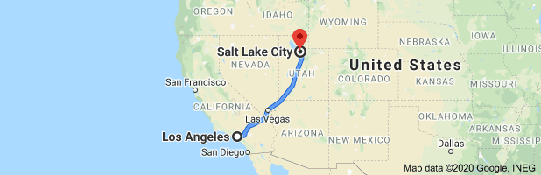
785. Los Angeles – a large city in the state of California (164)
786. Salt Lake City – a large city in the state of Utah (164)
787. consideration – thinking about something before making a decision (164)
788. celebrated – See Definition 21. (165)
789. test the climate – See how thing go; check out if it is all right for us [in Los Angeles]
(idiom) (165)
790. remaining – those still there (165)
791. glistened – shined; glowed; looked very nice (166)
792. City Hall – a city government building containing courtrooms, offices for people in charge of
different departments in the city government, meeting rooms and other official offices (166)
793. totally unfamiliar – We did not recognize anything about it; everything was strange to us. (166)
794. instant connection – I felt that I belonged and should be there [in Los Angeles]. (166)
795. majestic – wonderful and special; terrific; magnificent; outstanding (166)
796. birthplace – where I was born (166)
797. skid row – a place where homeless, very poor people live or hang out (idiom) (167)
798. derelicts – people who have nothing to do with their families (167)
799. drunkards – alcoholics; people who are drunk much of the time (167)
800. stench – awful smell; terrible odor (167)
801. urine – pee (167)
802. horrible – awful; disgusting; terrible (167)
803. traumatizing – adjective form of “trauma” (See Definition 606.) (167)
804. longed for – missed; wanted to see or be there again (167)
805. grotesquely – horribly; terribly (168)
806. abnormal – not normal; not the way you expect things to be (168)
807. circumstances – things going on (See Definition 244.) (168)
808. eventually – adverb form of Definition 736 (168)
809. routine - something you do over and over again; something you are used to doing (168)
810. lousy – here, tasting and even looking bad (168)
811. incarceration – See Definition 205. (168)
812. constantly – here, without stopping (168)
813. surroundings – places around or near you; environment (ex. buildings, stores) (168)
814. perpetual – always there; never seeming to end (168)
815. amazingly adaptable – able to get used to anything (168)
816. temporary – not forever; not permanent; for a short time (168)
817. filthy – very dirty; very messy (168)
818. racket – lots of noise (168)
819. flashing – quickly going on and off again and again (168)
820. challenging adjustment – a situation which will be difficult to get used to and do (168)
821. two-story – having rooms on two floors (168)
822. employment agency – a business to help people find jobs (169)
823. Little Tokyo District – neighborhood where mostly people of Japanese background live and
work (similar to a Chinatown in places such as New York City and Seattle, Washington) (169)
824. several – many (169)
Take a 23-minute tour of Little Tokyo in Los Angeles by watching the video on this Youtube site: https://www.youtube.com/watch?v=fcUd_tucz2k
825. assist – help (169)
826. back on their feet – back to doing well; return to success (idiom) (169)
Dry Cleaning store:
827. sustain – provide us with enough money (169)
828. making a commission – making any money (169)
829. struggling – See Entry 603. (169)
830. eventually – See Definition 808. (169)
831. sacrifice – do without (169)
832. dry cleaning business - a store in which you bring you clothing to be cleaned and ironed (169)
833. descended – walked own; went down (169)
834. barrio – Spanish-speaking section (neighborhood) of a town (here, Los Angeles) often
where mostly poor people live (170)
Panama Canal:
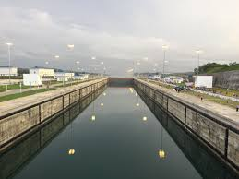
835. new rhythm – a new way of living and being with people (170)
836. rumors, gossip – See Definition 588. (170)
837. unexpected – surprise; not thinking that it would come (170)
838. miraculously survived – unbelievably lived when we thought they had been killed (170)
839. informing – telling (170)
840. apparently – Seemingly; as far as we know (170
841. canals – man-made waterways; water paths made by people (ex. Suez Canal; Panama
Canal) (170)
842. appeared – seemed; turned out (170)
843. perished – died; were killed (170)
844. back on track – back the way things used to be (before internment) (idiom) (170)
845. aftereffects – results or effects on us after what we went through during WW II, living in
the internment camps (prison camps for Japanese-Americans) (170)
846. tragic toll – horrible results; terrible emotional cost (170)
847. chilly air – unfriendly attitude (way of talking to or about me) (idiom) (171)
848. particularly – especially; mainly (171)
849. recess – free time; time in school for playing rather than learning (171)
850. opposite of inattentive – gave me too much attention; spent too much time on me (171)
851. watch me like a hawk – watch me very carefully (waiting for me to do something wrong)
a hawk has big eyes
(idiom) (171)
852. cut like a knife – really hurt (idiom) (171)
853. Jap – an insulting way to speak about a person who is of Japanese
heritage or background or family (171)
854. shame – See Definition 613. (171)
855. spewed – said in a nasty, angry way (172)
856. Pledge of Allegiance – words said to show how you love your country (172)
857. unsettling feeling – an upsetting, disturbing feeling that something is wrong (172)
858. pledge – promise (172)
859. allegiance – See Definition 393. (172)
860. republic - a nation in which power is held by the people and their elected representatives (172)
861. guilt … surrounded – the way we were made to feel that we deserved to be prisoners
because we were not as good citizens as other people (172)
862. nasty epithet – bad, insulting, hurtful name (here, a traitor or disloyal person) (172)
863. indivisible – cannot be divided or separated (172)
864. liberty – freedom (172)
865. justice – fair treatment under the law (172)
866. civics - the study of the rights and duties (responsibilities) of citizenship (173)
867. assault - an attack (173)
868. Constitution – See Entry 144. (173)
869. guarantees – promises (173)
870. due process – the right to a fair trial (173)
871. equal protection – the right to be treated fairly and not unfairly put on trial or arrested (173)
872. prejudice – See Definition 469. (173)
873. unleashed – allowed to act without being stopped (173)
874. unscrupulous – dishonest; corrupt; unable to be trusted (173)
875. politicians - people who try to get elected to public offices (173)
876. reconcile – make one idea work or exist with another (173)
877. shining ideals – wonderful, meaningful, great perfect ideas or hopes: one example of a
democratic ideal is that everyone will be treated fairly and equally (173)
878. unpleasant – not very good or nice; giving a bad, disappointing feeling (174)
879. stall – See Definition 166. (174)
880. chapters – parts or sections of a [history] book (174)
881. repeat – See Entry 86. (174)
882. Pacific Theater – the place in and near the Pacific Ocean where American soldiers,
sailors, marines and pilots fought against The Japanese (174)
883. enemy – See Definition 1. (174)
884. enrolled – was accepted to and went to [a college] (175)
885. UCLA – The University of California, Los Angeles (175)
886. theater – a place where you act on a stage (175)
887. opportunity – chance (as in Entry 250); something possible (175)
888. original musical – a new show with a story and singing and an orchestra (175)
889. shined a light – made known; made people pay attention to (idiom) (175)
890. political and social injustices – unfair ways of doing things in society and with elected
people, so that others were not treated properly or the way they should be (175)
891. auditions – tryouts; chances for actors or singers or musicians to show how good they
are, so that they can be put into shows (175)
892. pass up – ignore; skip; pay no attention to (175)
893. Fly Blackbird! – the name of the first show that George Takei is in on stage (175)
894. thunderous ovations – loud (thunderous) applause (ovations); noisy clapping (175)
895. optimism – the feeling that everything would be all right (175)
896. profound -deep; meaningful (175)
897. countless – too many to count; a whole lot (175)
898. spread a message – taught people a lesson (175)
899. positive change – a better future, when things would improve (175)
900. common future – a future shared by everyone (here, in the U.S.) (175)
901. like-minded – thought the same was [as George Takei did] (idiom) (175)
902. the course of the show – as long as the show ran, day after day (175)
903. backstage – the area behind the stage where the actors dress, put on make-up, and
meet people from the audience after the show (175)
904. permanently linked to – had a long-lasting [acting] relationship with (175)
905. unforgettable encounters – meetings I would never forget (176)
906. the production – the show on the stage (176)
907. various – different (176)
908. rallies – meetings to get people to support a person or a cause (purpose, such as equal
treatment of all people no matter which color they are (176)
909. Rev. Dr. Martin Luther King, Jr. - a leader of black Americans trying to get equal rights
in the 1950’s and 1960’s // Rev. = Reverend (religious leader; Dr. = holder of the
highest graduate degree from a college (Dr. King earned a Doctorate of Philosophy in
Systematic Theology from Boston University.) (176)
910. American Dream – Dr. King’s American Dream is defined in the 3rd panel page 176.
911. nationalities – here, ethnic groups that are part of America, such as African-Americans,
Japanese-Americans, Chinese-Americans, Hispanic-Americans. (176)
912. creeds – beliefs, such as religious ideas (176)
913. brothers – here, equals; people who care about and protect each other (176)
914. professed – talked in favor of; been on the side of (176)
915. practiced – acted or behaved in a certain way (176)
916. opposite – having a position on the other side; totally different (ex. slow and fast) (176)
917. challenged – asked to do something difficult (hard) but important (176)
918. noble dream – wonderful goal that will be fantastic if reached (achieved) (176)
919. reality – actually existing; true (176)
920. implement – make it happen (177)
921. saviors – those who rescue or make sure something happens (177)
921. spellbound – almost hypnotized; charmed; my attention was totally held by (177)
922. resonated – gained my complete agreement; matched my own ideas (177)
923. theater performer – a person who acts or sings on a stage in front of an audience (177)
924. captivated -held my complete attention (177)
925. entire arena – everybody who was in that place (a large hall) to listen to the speech (177)
926. backstage – See Definition 903. (177)
927. contribution - sometimes, money given but here, work Takei has done for a cause (177)
928. brief encounter – short meeting (177)
929. honor – a feeling of great respect; a feeling that makes you proud (177)
930. marching – walking alongside a group to show what you believe in (178)
931. unforgettable experience – a time I will never forget; something I will always remember (178)
932. equality – fair and equal treatment for all people (178)
933. seeds – start; beginning (178)
934. activism – taking part in meetings, demonstrations, and marches for an idea or right (178)
935. planted – set up; begun {finishing the metaphor that started with “seeds”} (178)
936. participatory – something which you take part or are active in (178)
937. existentially – in reality; really (178)
938. cherish – love; see as valuable; care very much about (178)
939. shining … ideals – See Definition 206. (178)
940. actively engage in – take part in; participate in; become involved in (178)
941. political process – the steps in either running to be elected or helping such a person (178)
942. Adlai Stevenson – the Democrat who ran against the Republican Dwight Eisenhower to
be elected U.S. President in 1952 (and again in 1956) (179)
943. headquarters – the office(s) where the main people on the side of a candidate (someone
trying to be elected) are working in his/her campaign, attempt to be elected (179)
944. action – movement; things happening (179)
945. risks – chances, especially those that may result in losing (179)
946. eloquent – spoke very well; made very interesting and meaningful speeches (179)
947. whispered – quiet; not loud (179)
948. swept across – went through (idiom) (179)
949. campaign headquarters – See Definition 143. (179)
950. No funny business – Don’t fool around; be serious (idiom) (179)
951. Mrs. Eleanor Roosevelt – the wife of President Franklin Roosevelt, the President who
ordered the Japanese-Americans into the internment camps at the start of WWII;
by this time, President Roosevelt had been dead about 8 years, but his wife remained
very active in political matters. (180)
952. volunteer – a worker who believes in a cause or purpose so much that he/she works for
that purpose (here, getting Stevenson elected) without getting paid (180)
953. on cloud nine – felt wonderful and excited and happy (idiom) (180)
954. name tag – a card you wear on your clothing so strangers can call you by your name (180)
955. missing – not there (181)
956. guest roles – parts in plays and TV shows but not where an actor appears all the time (183)
957. Hollywood productions – TV shows made in Hollywood, California (183)
958. conquerors - people who defeat and rule others (usually from other nations) (183)
959. mighty – powerful; very strong (183)
960. Playhouse 90, The twilight Zone, Mission Impossible – weekly TV shows in the 1950’s
and early 1960’s (183)
961. fortunate – lucky (183)
962. opportunities – See Definition 14. (183)
963. nationality – the national group you belong to, such as Asian or Hispanic or Caucasian (183)
964. played a big role – was very important (183)
965. bullied by authority – forced to do things you did not want to do by a powerful group,
such as the police or the government (183)
966. the American way – the way Americans are supposed to act (fairly, without prejudice,
honestly, kindly) (183)
967. RKO Studios – one of the five most important companies that made movies in the first
half of the 20th Century (183)
968. re-christened – re-named; given a new name (183)
969. Desilu Studios – the new name for RKO Studios (The name is a combination of the first
names of the two most important people who ran the company, Desi Arnaz and Lucille
Ball.) (183)
970. agent – a person who gets paid to find acting jobs for actors and musicians (184)
971. pilot – here, the first show made to try to get people to spend money and make a series
(See Definition 984) of shows with the same characters and story (184)
972. one-off – a one-time acting role (as opposed to being in the same show every week)
(idiom) (184)
973. steady work – regular work; repeated appearances on a show (184)
974. opportunity – See Definition 14. (184)
975. I Love Lucy – one of the most popular (most watched) TV comedies of the 1950’s (184)
*** See Lucy and Desi in a short funny part from their Tv show on the following film from
Youtube: https://www.youtube.com/watch?v=MdH-Ac3NK0M
976. immigrant from Cuba – Desi Arnaz, who was born in Cuba but came to the U.S. to live (184)
977. unpredictable – not able to tell what will happen (184)
978. Rodenberry – Gene Roddenberry, who made popular science fiction TV shows (made up
or fictional shows which had a lot of scientific ideas in them) (185)
979. “I really started off right with this one” – means just the opposite, that he had messed
up Mr. Rodenberry’s name so things were not going well; he as being sarcastic,
making fun of himself. (185)
980. glance – quick. brief look; gaze (185)
981. receptionist – the person who greets you and takes your name when you enter an office (185)
982. unnerved – shaken, weak, nervous (shaking) (185)
983. life-changing – something that is so important that it can make your life better (185)
984. series – a TV show that has many episodes or different stories week after week (185)
985. tense smiles exchanged – looked at each other and smiled in an uncomfortable way (185)
986. intercom – a machine people in different offices in the same building could speak to each
other with (185)
987. mercifully – kindly; in a way that made me happy and less nervous (185)
988. buzzed – made a noise to get my attention (185)
989. pleasant conversation – a nice talk with each other; a friendly chat (186)
990. pronunciation – how you say something (186)
991. rhymes with – sounds like (186)
992. spontaneous – natural; not planned (186)
993. unaffected manner – a way of doing something that is not phony, that is natural (186)
994. comfortable – at ease; relaxed; calm; not the smallest bit nervous (186)
995. bunlike – not like; not compared to (186)
996. producer – The producer of a TV show does the following things:
- assists the executive producer(s), who are people who watch over the contents and costs of a TV show or series of shows
- picks scripts (the written dialog spoken between actors) and introduces new ideas
- watches other producers and makes sure they, and the show, work within union rules, such as how much time an actor works in a day and how long a lunch break is
- assists with the hiring of talent (actors, singers, musicians) and other crew members, such as people who work the cameras and the lighting
- is in charge of the post-production process (what is done after each show is finished)
- maintains the budget (stops spending too much) and approves schedules
- gets legal rights to make TV shows out of books or other works (such as scripts for shows that first appeared on stage somewhere, such as Broadway in Manhattan) (186)
997. Twenty-third Century – The TV series that Takei acts in is set in the 2200’s, the future (186)
998. aboard – on (186)
999. a Spaceship Earth – a ship traveling through space with people from all different nations (186)
1,000. character’s name – the name of the person on the show whom you (Takei) will play (187)
1,0001. bright – intelligent; smart (187)
1,002. science officer – the person in charge of experiments and all decisions that need
knowledge of science to make the right choices (187)
1,003. pan-Asian heritage- the character or his/her family has to come from an Asian nation,
such as China, Korea, Japan, the Philippines, India, Thailand, or Burma (187)
1,004. represent – stand and speak for [an entire group] (187)
1,005. unflattering – not showing or saying good things; insulting (187)
1,006. stereotypical depictions – showing (depicting) people of one race or ethnic background
acting all the same, in a way that shows bad or stupid ways of doing things (ex.
showing all Asian characters as great at math or all Jewish people as greedy) (187)
1,007. likeable – someone the viewers will like and enjoy seeing (187)
1,008. buffoons – clowns; foolish, silly people {See the picture below.} (187)
1,009. menials – people who can only work as servants but can never be in higher positions (187)
1,010. menaces – dangerous people; villains (very bad people); criminals (187)
1,011. officer – leader, with a high rank (position) (187)
1,012. carrying his weight – doing work as an important member of the crew (the people on
the spaceship) (idiom) (187)
1,013. sheepishly – in a shy way; quietly and nervously (187)
1,014. apologized – said that he was sorry (187)
buffoons:
1,015. legacy – what happened before (187)
1,016. opportunity – See Entry 250. (187)
1,017. believe it or not – it is true even though it is hard to believe (188)
1,018. Star Trek – the name of the TV series (See Definition 984) that Takei is being hired to
act in; the name means “travel (Trek) through the stars and planets, etc. (188)
1,019. my shot – my chance (188)
a scene from the Tv show Star Trek:
1,020. title – the name of the TV show (188)
1,021. pilot See Definition 971. (188)
1, 022. tough – difficult (188)
1,023. Hamburger Hamlet – name of a fast food restaurant, similar to McDonald’s (188)
1,024. unusual – different; not the way you often do something (188)
1,025. dropped the cool façade -stopped acting calmly and in control (idiom) (188)
1,026 protects our egos – keeps us from having hurt feelings (188)
1,027. this profession -acting (188)
a bois (in France):
1,028. role – part [in a show] (188)
1,029. desperately – really; very much (188)
1,030. far out – unusual (See Definition 1,024.) (idiom) (188)
1,031. shooting craps – taking a big chance; gambling; taking a risk (See Definition 711.)
(idiom) (188)
1,032. “So…maybe it sells” – maybe the show (Star Trek) will be put on the TV with me
in an important role (See definition 956.) (idiom) (188)
1,033. bois – forest, an area with many trees // In the story pictured, Sulu (the part played by
George Takei in Star Trek) imagines that he is a warrior (fighter) in old Japan. (189)
1,034. bloodied – hurt by my sword (189)
1,035. my blood on your swords – I’ll be dead, killed by you. (189)
1,036. lieutenant – an officer; a leader just below the rank (See Entry 1,011) of captain (189)
1.037. represent – act or speak for a group of people similar to me (189)
1,038. Asian heritage - See Definition 1,003. (189)
1,039. honor – respect; a good feeling; pride (See Definition 693.) (189)
1,040. silver screen – movie (After Star Trek finished its three-year run on TV, there were
several Star Trek movies with many of the same actors.) (idiom) (189)
1,041. commander, captain – higher ranks than lieutenant, with more important things to do //
Captain is the second highest position or rank, just below admiral; it means that Sulu
was in control (in charge) of an entire spaceship in one movie. (189)
1,042. Stardate 9521.6 – This is a date from a future calendar used in the show by the United
Federation of Planets, kind of a United Nations but with members from many types of
beings from many planets trying to have a peaceful universe and fighting together
against war-like planets. (189)
The flag of the United Federation of Planets:
1,043. log – record; journal; diary (189)
1,044. USS Excelsior – name of the Spaceship on
which Sulu was captain (189)
1,045. commanding – in charge; leading (189)
1,046. notoriety – here, fame (189)
1,047. platform – position (189)
1,048. address – speak about (189)
1,049. social causes – problems in American society that are in the way of everybody being
treated with fairness (189).
1,050. musical – See Definition 888. (190)
1,051. Allegiance – This is the name of the stage show that had George Takei acting in it. (190)
1,052. Broadway – an area in Manhattan, New York City in which there are several streets
with theaters in which are shown plays, some with just talking and some with music
as well as talking (190)
1,053. debut – opening; the first time a show is presented to an audience (190)
1,054. starred -was the main actor or performer (190)
1,055. talented cast – a group of actors with great ability or skill (190)
1,056. primarily – mainly; mostly (190)
1,057. extraordinary – amazing; sensational; wonderful; outstanding (190)
1,058. internment – See Definition 205. (190)
1,059. wider audience – a large number of people [who would see the show] (190)
1,060. during its run – while the show was playing on Broadway (190)
1,061. members – part of a group (here, the audience watching the show) (190)
a scene from an internment camp:
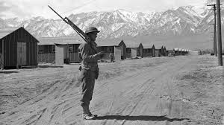
1,062. roughly – approximately; about the number of (190)
1,063. incarcerated – See Entry 142. (190)
1,064. performance – presentation of the show (191)
1,065. surprise – not expected; unplanned (191)
1,066. particular -special; specific (191)
1,067. visitor – someone present who is not usually there but just came to see a person (such as
an actor) or a place or an event (such as a show) (191)
1,068. secretary – the worker who writes and makes phone calls and does other similar jobs
for a boss (191)
1, 069. enjoyed – had a good time (191)
1,070. husband – George Takei is gay (a homosexual) and is married to a man named Brad. (191)
1,071. rascal – a child who likes to fool around, make jokes, and cause problems (191)
1,072. Hyde Park – a place in New York State where President Franklin Roosevelt lived (192)
1,073. Ronald Regan – President of the U.S. from 1981 to 1989 (192)
1,074. on behalf of – representing; speaking for (192)
1,075. apologized – See definition 1,014. (192)
1,076. grave mistake – very serious and harmful error; something horrible done wrong (192)
1,077. granting internees – awarding to or giving to those who had been locked up in the
internment camps (192)
1,078. $20,000 – the amount of money to be given to former internees; that much money would
be worth $44,536.22 in 2020. (192)
1,079. redress – trying to make right something unfair that happened (192)
1,080. relocated – See Definition 507. (192)
horse manure:
1,081. stalls – See Definition 166. (192)
1,082. fresh – newly made (192)
1,083. manure – See Definition 162. (192)
1,084. build pressure – try to force people to do something (192)
1,085. witnesses – people who saw what was going on (192)
1,085. testify – tell in court what you saw happening (192)
1,086. Commission on Wartime Relocation and Internment of Civilians – the group of
people from the government who were studying what to do to pay for making
American citizens go into the internment camps even though they had done nothing
wrong, without even having a trial (192)
Pearl harbor after the bombing:
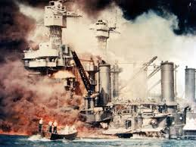

1,087. gather – get together; meet (192)
1,088. grave – See definition 77. (192)
1,089. shortly after – soon after (192)
1,090. Pearl harbor – See Definition 32. (192)
1,091. ancestry – family background; where your family and past relatives first lived (192)
1,092. forcibly removed – made to leave because if they did not they would be hurt (192)
1,093. makeshift – quickly but not well made (192)
1,094. internment camps – See Definition 419 or 845. (192)
1,095. based solely on race – [Putting people into the internment camps was] done only
because they had Japanese families. (192)
1,096. descent – which race or group their families were part of (192)
1,097. By this point – By this time (192)
1,098. incarcerated – See Entry 142. (192)
1,099. elected into Congress – voted to become members of the U. S. Congress (either the
House of Representatives or the Senate) (192)
1,100. high offices – important government positions (192)
1,101. legislation – law (193)
1,102. restitution payment – money given to pay back for unfair behavior (193)
1,103. detained – held against their will; not allowed to be free (193)
1,104. reaffirm our commitment – state again our wanting to do the right thing (193)
1,105. equal justice under the law – everyone is treated the same in courts and by police (193)
1,106. letter of apology – a letter saying that they made a mistake and were sorry (193)
1,106. George H. W. Bush – President of the U.S. from 1989 to 1993 (193)
1,107. “The wheels of Democracy turn slowly.” – It can take a long time in a democracy until
the right things happen. (193)
1,108. donate – give away (193)
1,109. founding – getting started; establishment; beginning the steps to building (193)
1,110. amazing statement – wonderful point; terrifically important words (193)
1,111. apologize – See Definition 1,014. (193)
1,112. passed – died; passed away (193)
1,113. wrongdoing – mistakes; errors (193)
1,114. disastrous – horrible; harmful; causing a lot of pain and difficulty (194)
1,115. Depression – a period of time in the U.S. mostly in the 1930’s when many people had
no money and no jobs and therefore no food [except what churches and other groups
could give them] and suffered a lot (194)
1,116. pulled us out of it – ended the Depression (or Great Depression) with a series of moves
made by the U.S. government led by President Franklin Roosevelt (idiom) (194)
1,117. Free Soup / For the Unemployed – {what the sign in the first panel says} soup that you
do not have to pay for (because most people had no money) for people without jobs
(unemployment) (194)
1,118. determination – deciding to do something and not stopping till it was done (194)
1,119. creative energy – new ideas; new solutions to problems (194)
1,120. establish -to start; to get going (194)
1,121. lift the fortunes – make the economy better; help people earn money / get jobs (194)
1,122. openly and candidly -for people to hear on radio, TV, in public (openly) and honestly
(candidly) (195)
1,123. fallible – not perfect; had faults or weak qualities; did some things wrong (195)
1,124. disastrous – See Definition 1,114. (195)
1,125. calamitously – causing great damage or harm; very hurtful and painful (195)
1,126. despite – without being affected by; in spite of (195)
1,127. people’s democracy – rule by governments elected by the citizens of the U.S. (196)
1,128. overcome – succeed [in gaining fair treatment] even though we will struggle for this
right (by demonstrating, discussing, marching, voting, striking) (196)
1,129. after-dinner – after supper (196)
]1,130. informed - formed; influenced; shaped (196)
1,131. worldview – the way I see the world and the way people work and their thinking (196)
1,132. initiate – start; begin (196)
1,133. instilled – put into (196)
1,134. affiliated with – associated with; connected with; having to do with (196)
1,135. NPR’s – belonging to the National Public Radio network, a series of radio stations in
different states which receive money from the government rather than from ads (196)
1,136. “Weekend Edition” – the name of a weekly NPR show (196)
1,137. tarpaper barrack – poorly built room made with cheap materials where George went to
school while he was in the internment camp (196)
1,138. barbed-wire fence – See Definition 384. (196)
Supreme Court Building:
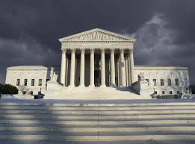
1,139. carried on – moved forward; improved; gotten better (197)
1,140. high office – See Definition 1,100. (197)
1,141. faithful – See Entry 100. (197)
1,142. ideals – See Entry 206. (197)
1,143. forbears – the people who lived before we did [in the U.S.] (197)
1,144. embraced with conviction – accepted with belief in and wanting to follow (197)
1,145. old outrages – insults and hurts from many years ago (197)
1,146. resurface – come back; become known again (197)
1,147. brutal – terrible; painful; hurtful (mostly emotional) (197)
1,148. Utah - a state in the U.S. (home of Salt Lake City – See Definition 786. (198)
1,149. Topaz Relocation Center – one of the 10 internment camps (See Entry 251) (198)
1,150. refused – ho would not go; he would not follow the order to move (198)
1,151. appeals process – after losing the trial, this is the next step; you appeal to a higher
court; your argument is heard by different judges, who then decide whether or not
you are right (198)
Supreme Court judges in 1944:
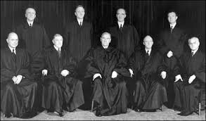
1,152. eventually -See Definition 808. (198)
1,153. Supreme Court – See Entry 96. (198)
1,154. fared similarly – got the same results (198)
1,155. excluded – left out; omitted; excused (199)
1,156. military area – army, navy, marines: fighting men (women were not allowed to fight in
wars at that time) (199)
1,157. hostility – angry feelings; disagreement (199)
1,158. Justice Hugo Black – one of the nine judges on the Supreme Court in 1944 (199)
1,159. rulings – court decisions; legal conclusions (200)
1,160. Constitutional – legal, according to the U. S. Constitution (See Entry 144) (200)
1,161. officially overturned – reversed / said the opposite by the 2018 Supreme Court (200)
1,162. breaking – news that has just happened and is now being told (200)
1,163. Justice Roberts – Chief Justice of the United States (200)
1,164. statement – what he said about the law (200)
1,165. a cruel irony – a hurtful twist in which the opposite of what you want happens (200)
1,166. struck down – said that it was not and should never have been legal or allowed (200)
1,167. side note - a comment that was not part of the bigger decision about another case (200)
1,168. upheld – said that something done was legal and allowed (200)
1,165. ban – a law not allowing or permitting something to happen (201)
1,166. Muslim countries – nations in which most people follow to Muslim religion; this ban
included Iran, Iraq, Libya, Somalia, Sudan, Syria and Yemen. (200)
books about another internment camp:
1,167. are unable – cannot; are not allowed to (201)
1,168. process – See Definition 110. (201)
1,169. request – what you are asking to be done (201)
1,170. barred – not allowed; kept; prevented (201)
1,171. abomination – horror; disgusting action (201)
1,172. Justice Sonia Sotomayor- the first Hispanic Supreme Court justice (judge), who became
a member of the Supreme Court in 2009 (201)
1,173. voice of dissent – wrote an explanation about why she disagreed with the decision of
most of the Supreme Court (5 or more of the 9 judges, called justices) (201)
1,174. overruling Korematsu – changing the previous decision made in 1944 which had said
that detention was a military necessity (need) not based on race; this new ruling
says that it was a racist decision that never should have been allowed (201)
1,175. sanction - allow, legally (201)
1,176. discriminatory policy - a way of doing things that is unfair to certain groups of people
because of their race, age, sex, homosexuality, being handicapped, etc. (201)
1,177. motivated – caused; made to happen (201)
1,178. animosity – anger toward or dislike of or hatred of (201)
1,179. disfavored group – people who are not treated in a friendly or fair way (201)
1,180. redeploys – uses in a new way (201)
1,181. logic – way of reasoning that seems to make sense (but here just causes pain) (201)
1.182. underlying – an idea that shapes the meaning of what is done (201)
1,183. refugees – people who come to a nation to be safe (201)
1,184. ban – See Definition 1,165. (201)
1,185. Wall – refers to the wall that Pres. Trump tried to build to separate the U.S. from
Meixico to keep non-U.S. citizens from entering the U.S. illegally, and which to many
Americans is an unfair move which is against Hispanic people, which is why there have
been marches and protests against building that wall (201)
1,186. merely – only (201)
1,187. replaces – takes the place of; is switched or substituted for (201)
1,188. gravely - seriously and harmfully; tragically (201)
1,189. proud – See Entry 929. (202)
1,190. cherished ideals – beliefs of a better [democracy] that someone thought to be very
important (202)
1,191. opportunity – See Definition 887. (202)
1,192. touches lives – affects or influences the way people live (202)
1,193. impossible – not possible; not able to be done (202)
1,194. @georgehtakei – Takei’s Facebook page: https://www.facebook.com/georgehtakei/
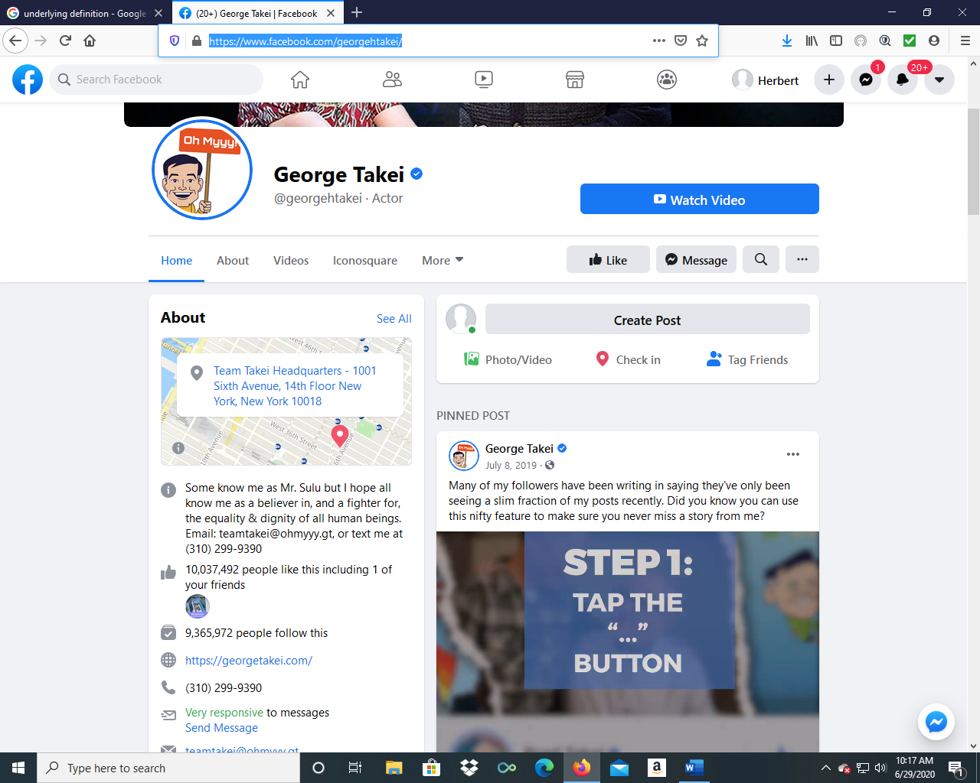

1,195. treating us like animals – act to us in an unfriendly way that shows that they don’t think
we are as good as they are (idiom) (202)
1,197. hold head high – show that you are proud of who you are and which race or ethnic
group you belong to (here, of Japanese ancestry – See Definition 1,091.) (idiom) (202)
1,198. Broadway – See Definition 1,052. (202)
1,199. life’s journey – life’s story (202)
1,200. exhibit – a group of objects and writings you can see and visit (202)
1,201. New Frontiers – the title of the exhibit in the Japanese-American National Museum in
Los Angeles which shows things that have to do with George Takei’s life; In hi TV
show Star Trek, “new frontiers” meant new worlds that the space explorers would be
visiting; also, there is a series of 32 novels about the characters in Star Trek and those
novels, mostly created (started) by John J. Ordover and Peter David and published by
Pocket, are in a series of books called Star Trek: New frontier. (202)

1,202. accomplished – achieved; done with success (202)
George is talking to his dead father’s ashes, being kept in one of the drawers in the picture, in a container such as an urn (which is like a closed vase that holds flowers – look it up). His father was not buried in the earth; his body was burned completely, and the ashes were placed into a container that probably looked like this:
1,203. -
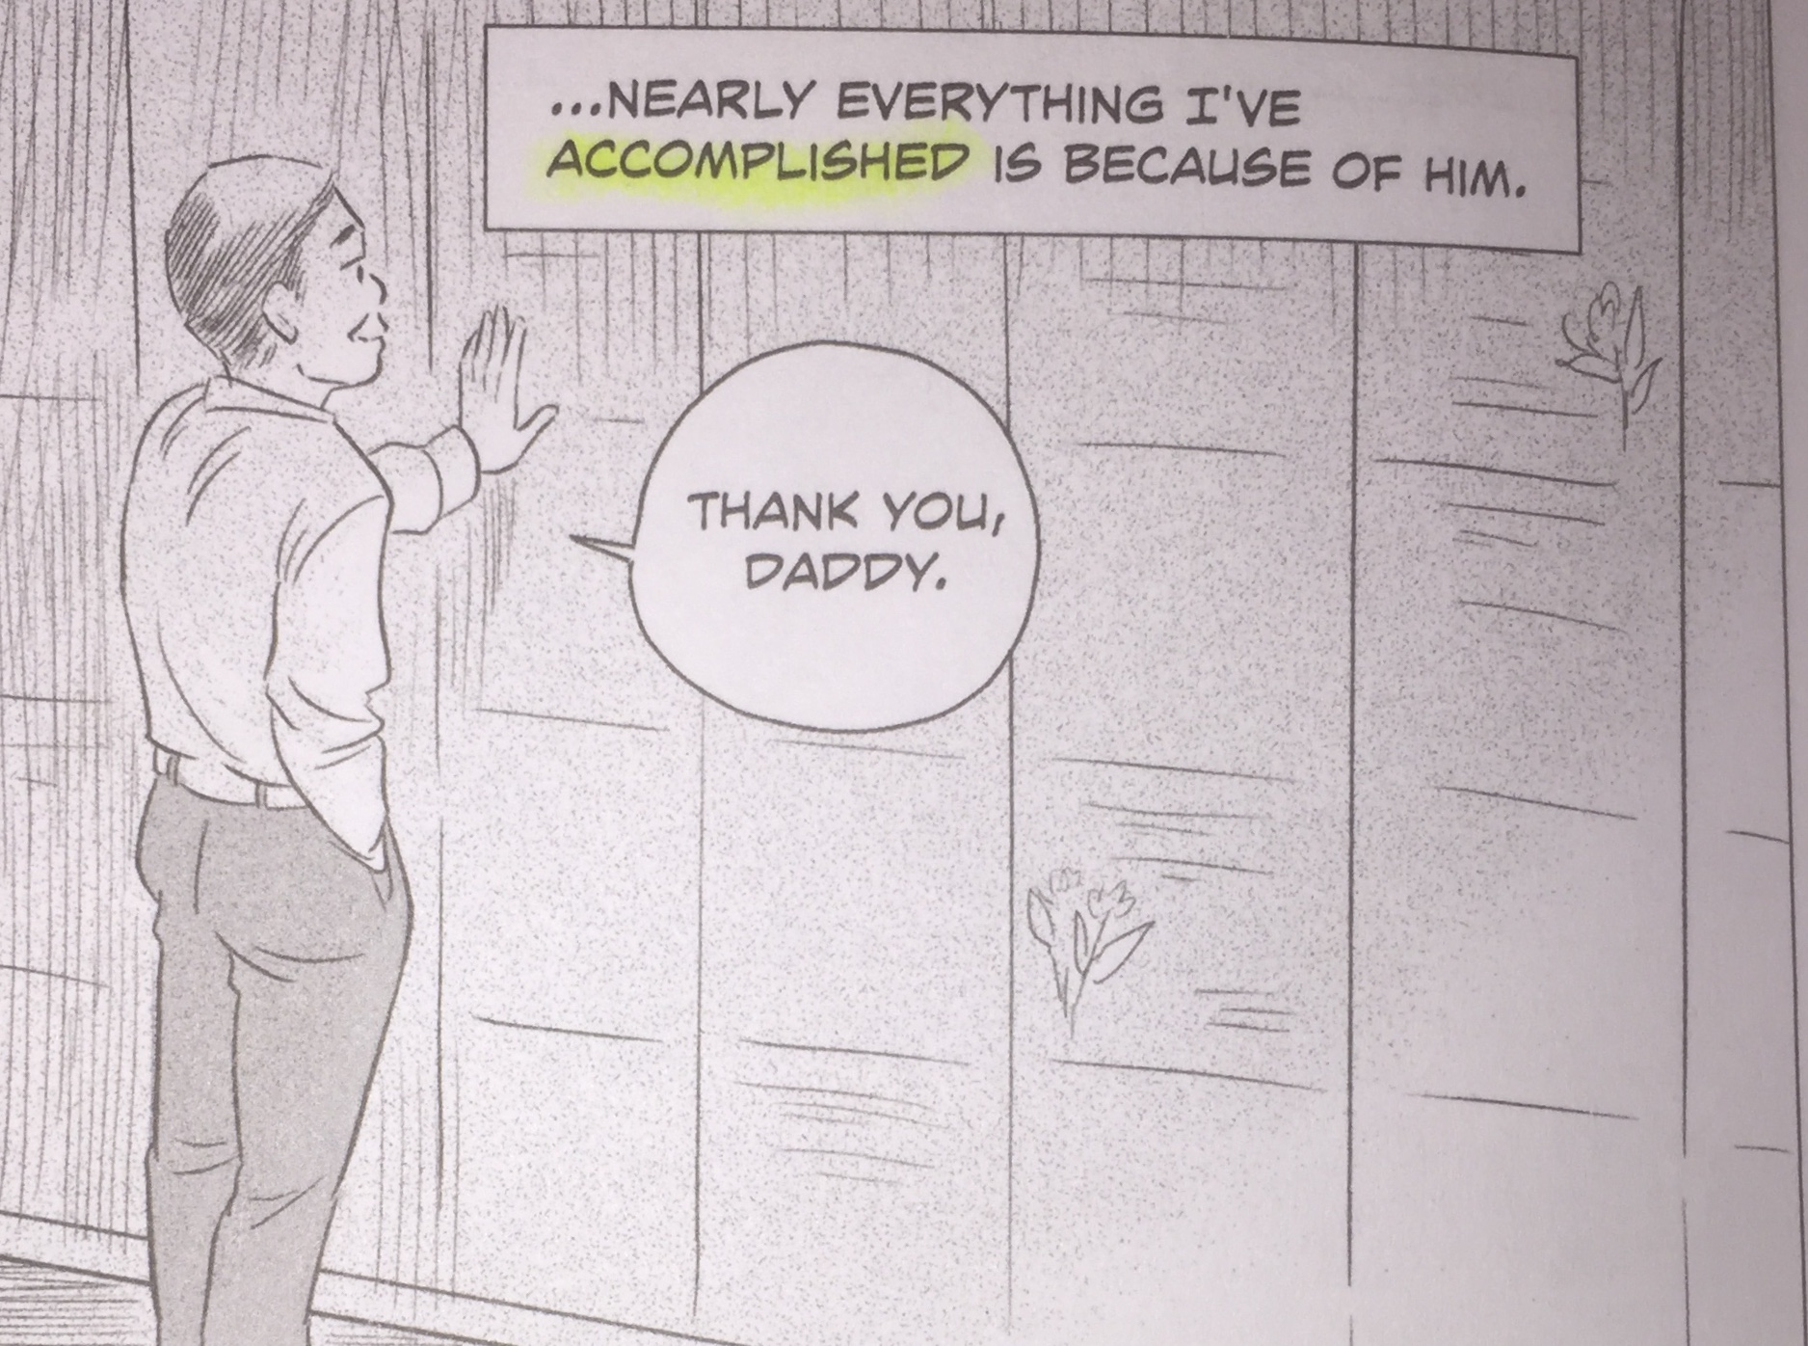

1,204. epilogue – an added part at the end
of a book that helps conclude or
finish the story (203)
1,205. justice – fairness; fair and equal treatment (how you treat other people) (203)
1,206. sword – a sharp blade meant to hurt or kill (203)
a sword and a shield:
1,207. shield – something held to protect yourself (203)
1,208. progress – moving ahead and getting better (203)
1,209. memorial – a place or act that helps you remember (203)
1,210. liberty – See Definition 862. (203)
1,211. manual – a book of instructions, telling how to do or
make something (203)
1,212. avoid – not to do or say something (203)
1,213. Barack Obama – President of the U.S. from 2009 to 2017; pictured on p. 197, first
panel (203)
BONUS VOCABULARY WORDS
“ABOUT THE CREATORS”
1,214. spanning six decades – covering 60 years
1,215. acclaimed -well-known and called well done
1,216. helmsman – the person who steers the spaceship
1,217. wrongfully – not correctly; unfairly
1,218. LGBTQ – people of all sexual ways (Lesbian, Gay, Bisexual, Transgender, Queer)
1,219. marriage equality – the right of people of the same sex to get married as much as
people of opposite sexes do
1,220. powerful voice – someone people listen to and pay attention to
1,221. pop culture – the latest things going on in the arts (music, art, dance, acting)
1,222. most influential – has the biggest effect on people’s opinions
1.223. passionate advocate – someone who shows great feelings when he speaks in favor of
1,224. outspoken – willing to say things even if they are not popular
1,225. supporter – someone who is in favor of a cause or movement
1,226. community activist – makes speeches and does things for equal rights where he lives
1,227. spokesperson – a person willing to make speeches for important causes
1,228. “Coming Out Project” – a movement helping homosexuals who want to make it public
1,229. Cultural Affairs Chairman – person who is mainly responsible for activities involving
such things as speeches, art and music shows, public discussions, etc.
1,230. emeritus -one who used to have a title but is now retired from that position but is
allowed to keep the title as an honor
1,231. trustee – a legally trusted member of a board or committee
1,232. appointed -officially named to [a board or committee]
1,233. President Clinton -See Definition 474.
1,234. Order of the Rising Sun, Gold Rays with Rosette – a medal that Japan gives someone as
The Order of the Rising Sun:
a great honor and a show of great respect
1,235. contribution – what you do to get something finished
1,236. relations – exchange of ideas and actions
1,237. decoration – medal given as an honor (See the picture)
1,238. conferred – given; awarded
1,239. emperor – like a king; a leader born into a royal family
1,240. Imperial Palace – the home of the emperor, with many rooms
1,241. Tokyo – the largest city in Japan
1,242. editorial director – person in change of publishing / printing books
1,243. graphic novels – books with stories that are told with many pictures, as is this one
1,244. collections – groups of similar books
1,245. publishing – printing and selling [a book]
1,246. immersed in – totally or completely involved in or concerned with
1,247. fateful encounter – meaningful and important meeting
1,248. adapting – putting into a different form (ex. from a book to a TV script of words to be
spoken by the actors)
an inline skate:

1,249. engaging – interesting; attention-holding
1,250. non-fiction – true stories (not made up or fiction)
1,251. spare time – when you are not working at your job
1,252. inline skating – moving on inline skates, which have two to five wheels arranged in a
single line
examples of publications:
1,253. debut – See Definition 1,053.
1,254. notably – obviously; clearly
1,255. publicist – a person with the job of making a product or book known to many people
and bookstores where that book might be sold; uses ads and interviews on the book
1,256. publications – print magazines and newspapers plus online sites
1,257. blogger / columnist – a person who writes about different topics, such as books; the
word “blog” stands for “web log” or a series of writings appearing online.
1,258. illustrator – person who draws picture, here, especially for graphic novels
1,259. creator – the person who first makes or builds something for others to see, read, hear
1,260. multicultural – people with different racial or ethnic backgrounds; mixed races
1,261. theme – main idea; mainly, what the story is about, such as the experiences that
George Takei had in his life, from his childhood to the internment camps to his acting
1,262. language barrier – difficult time understanding someone because you speak different
languages
1,263. shapes – what makes a person do or say the things he / she does
1,264. relationships – how people act with each other
1,265. currently – right now; today; at this time
1,266. Ohio - a state in the U.S., with cities such as Cleveland and Cincinnati

“ACKNOWLEDGEMENTS” (which means people you are thanking for their help)
1,267. grateful – thankful
1,268. stern organizational support – strong help in organizing or putting things together
1,269. amazing artistry – great skill in drawing (showing details, emotions, accuracy)
1,270. dedication – great caring
1,271. expert guidance – making fine suggestions
1,272. entrusting – trusting or believing in; having faith in
1,273. proud – See Entry 202.
1,274. created – See Entry 1,201.
1,275. sincere appreciation – honest thanks; real gratitude
1,276. endeavor – effort; work
1,277. a better tomorrow – a better future; an improved future (idiom)
1,278. throughout – all during; all while
1,279. grateful – See definition 1,267.
1,280. encouragement – words said to make you want to and feel you can do your work or tell
your story
1,281. inspiring words – See Entry 1,280: the meaning is the same.
1,282. propelled – made to move ahead or progress
1,283. having my back – being there to help me (idiom)
1,284. day one – the start; the beginning (idiom)
1,285. project – a group of related jobs or tasks
1,286. greater heights – more success (idiom)
1,287. imaginable – possible; can be imagined or thought of
1,288. grateful – See definition 1,267. (Yes, again: This is a section in which people are saying
how much they appreciate the help that others gave them. They are acknowledging
all this help.)
1,289. taking a chance – risking (See definition 711.)
1,290. entrusting – See Definition 1,m272.

“FRONT FLAP”
1,291. captured hearts and minds – got people to like him and listen to him (idiom)
1,292. worldwide – in many nations all over the world
1,293. captivating stage presence – when he is on stage, everyone pays attention to him
1,294. outspoken – See Definition 626.
1,295. commitment - See Definition 779.
1,296. new frontiers – See Entry 1,201.
1,297. uncertain future – a future time when no one knows what will happen
1,298. descent -See Definition 1,096.
1,299. west coast – here, California
1,300. rounded up – gathered; collected; put together
1,301. shipped – sent
1,302. relocation centers – internment camps (See Definition 251.)
1,303. armed guard – watched by soldiers with guns to shoot them if they tried to leave
1,304. firsthand account – a story told by someone who lived it and saw it happen
1,305. barbed wire – See Definition 384.
1,306. legalized racism – racism allowed by the government
1,307. hard – See Entry 93.
1,308. faith – belief
1,309. planted the seeds – set up; started (idiom)
1,310. astonishing – amazing; fantastic; unbelievable

“BACK FLAP”
1,311. decide – to make a choice or a decision
1,312. co-writers – people who worked together to write a book
1,313. artist – person who drew the pictures [in the book]
1,314. journey of a lifetime – trip through a person’s life; following someone’s life story or
biography
BACK COVER
1,315. reveals – shows; uncovers something that was hidden or unknown
1,316. incarceration – See Definition 205.
1,317. compelling – here, holding your attention
1,318. a must-read – a story that you have to read because it says important things (idiom)
1,319. founder - the person who starts a business or group
1,320. executive director – the person in charge; the person with the most important job
1,321. institute – a school, company or organization, often with the goal of teaching or
developing and presenting an idea
1,322. stunning – amazing; worth paying attention to
1,323. memoir – a story based on someone’s memories of what happened to him or her
1,324. revisits – [mentally] goes back to; remembers
1,325. concentration camp – similar to the internment centers, these were places where the
Nazis forced people they were going to kill to live so that they would all be in these
places and easy to kill when the Nazis decided to do that, often by gassing or burning
them. Such victims included Jews, homosexuals, priests, gypsies, soviet prisoners of
war, and Jehovah’s Witnesses (a religious group). These people did nothing wrong, just
as the Japanese-Americans did nothing wrong.
1,326. imprisoned – locked up
1,327. icon – a person who gets and deserves great respect from many people
1,328. gripping – holding your attention; here, making you want to keep reading
1,329. courage – See Definition 502.
1,330. loyalty – See Definition 395.
1,331. Top Shelf Productions – the company that printed this book and made it available to
sell in bookstores and online, at such sites as Amazon.com, bn.com, etc.

*****************************************************************************
INTERESTING ONLINE RESOURCES
WEBSITES
https://www.latimes.com/entertainment-arts/books/story/2019-09-24/george-takei-discussion-guide-they-called-us-enemy-book-club
This is a guide with discussion questions about topics in the book.

https://www.hbook.com/?detailStory=review-of-they-called-us-enemy
This site has a short review of the book.

http://www.tcj.com/reviews/they-called-us-enemy/
This is a longer review of the book.
INTERESTING ONLINE RESOURCES
YOUTUBE VIDEOS
If you go to youtube.com and search internment camps, you will find such videos as these:
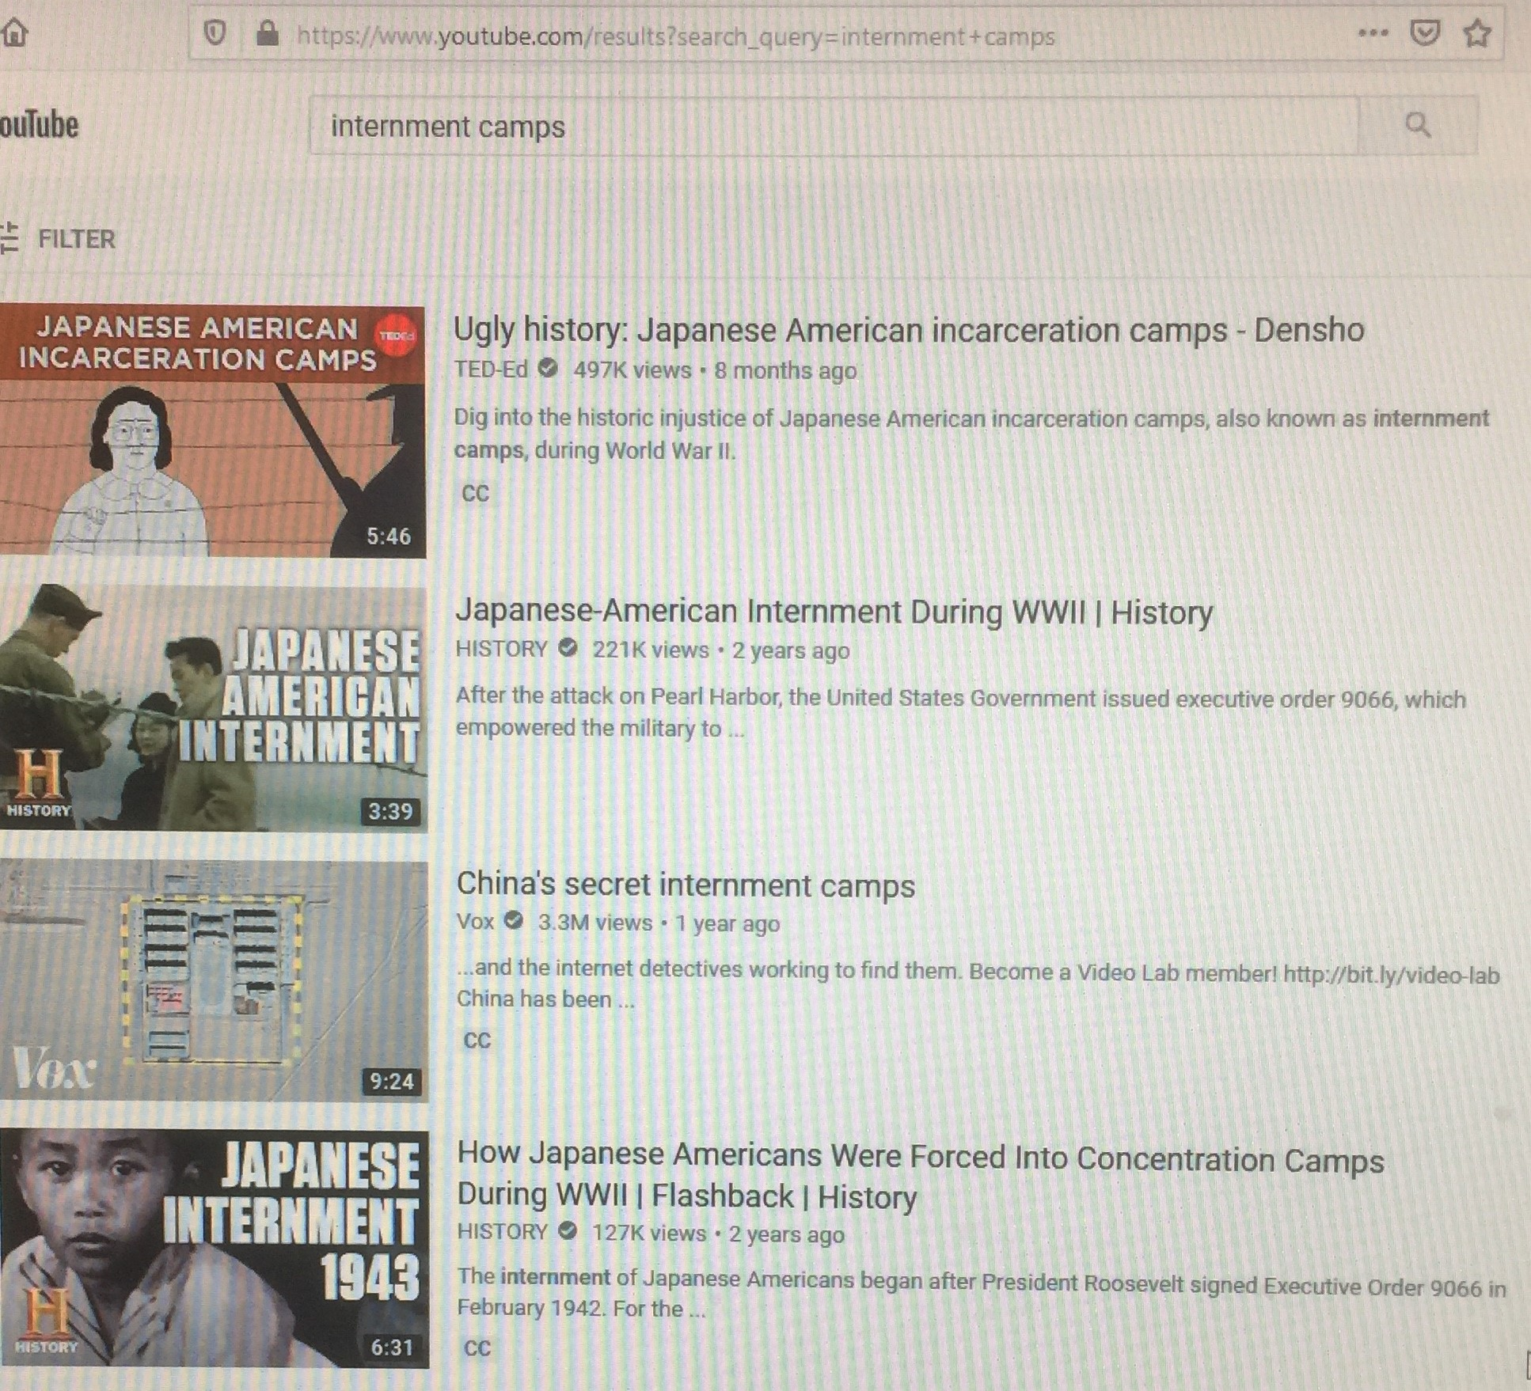

Go to this youtube.com site for an interview with George Takei about this book:
https://www.youtube.com/watch?v=TzlRy2EsZZs
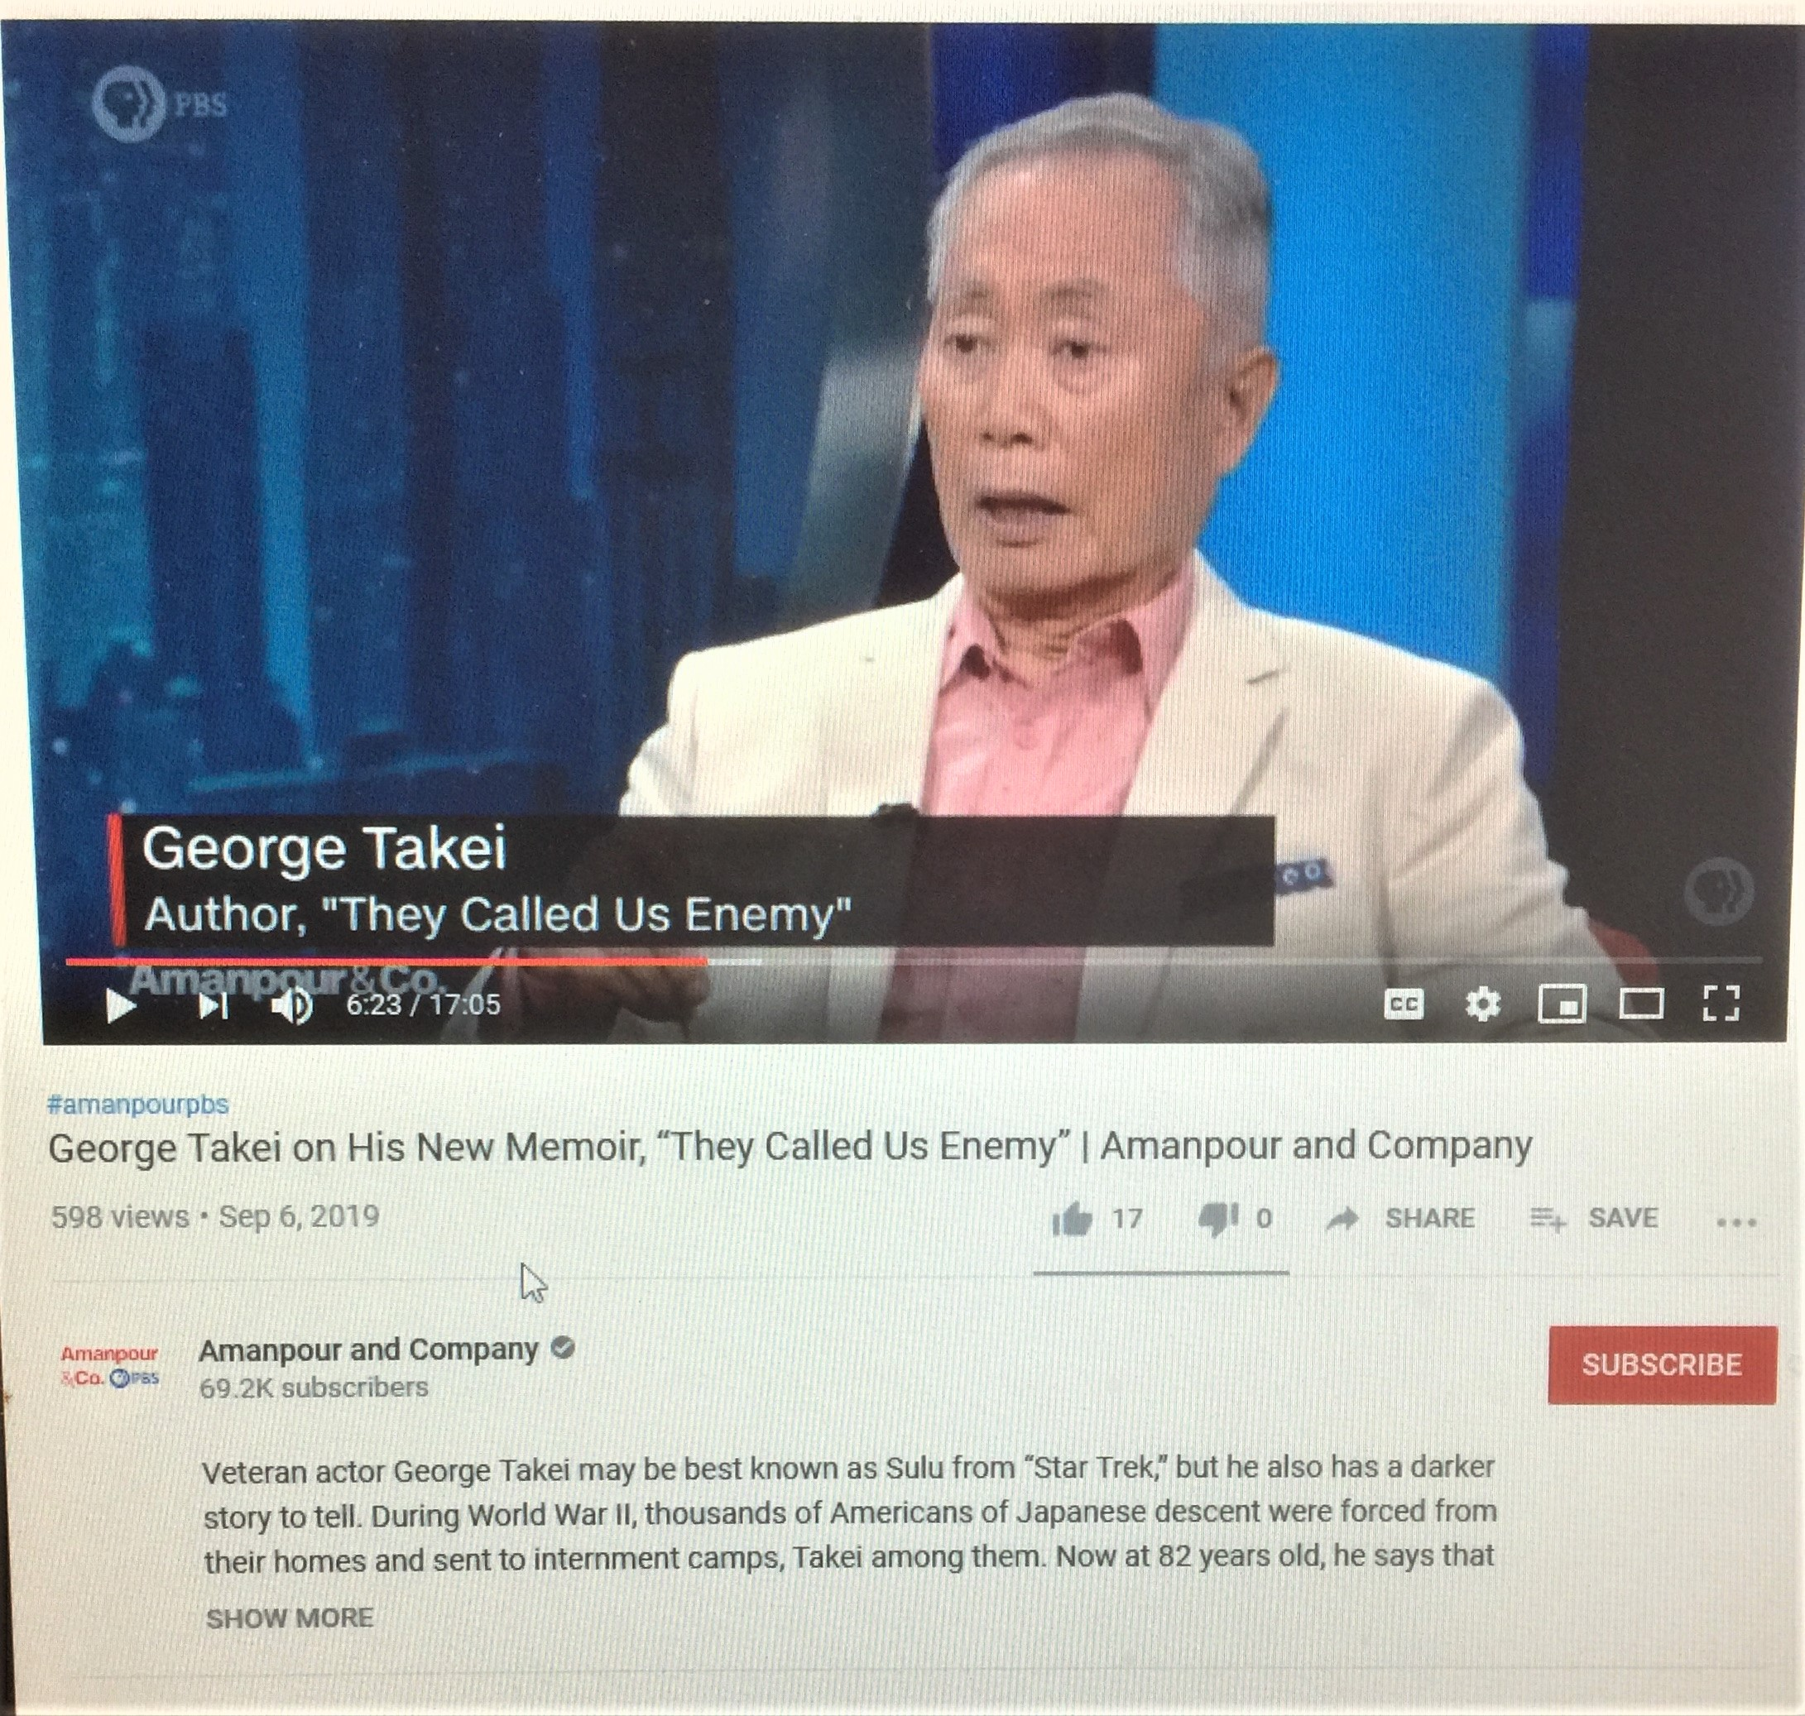
to watch a short film of Takei as spaceship Captain: https://www.youtube.com/watch?v=Y69Mp1Gi7qM
